ACCOUNT STATUS - DEBTORS

This process armAccStatus, allows you to maintain a file of account statuses, which can be associated with each of your customers and can cause special processing to occur when entering Invoices or Orders or Jobs etc.

Each status code can restrict the entry of Customer Orders and/or Invoices and/or Jobs (if using the Job Costing System) and/or Service calls (if using the Service System).

From time to time you may need to change the account status for a customer. You may want to stop Invoices from being raised, as an example, if the Account is overdue. The account might fall outside your ‘normal’ trading terms and you want to put the account on ‘stop’ until it is paid or perhaps the account has been on ‘stop’ and it has now been paid, so you now want to remove the stop. There could be many reasons why you want to change the status of an Account.

To set up Account Status entries, navigate to the Account Status process in the Accounts Receivable, Maintenance Menu – Account Status armAccStatus process.

Fields indicated as mandatory (Red Label eg. Status Code) require data input where other fields do not necessarily require data input, but these fields can be changed if necessary.
To access Help for all fields – position cursor in the field and press F1 or click on 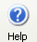Help button.

To access Search for fields that have Search available – position cursor in the field, Click on Search Button, or right click and select Search option.

ACCOUNT STATUS

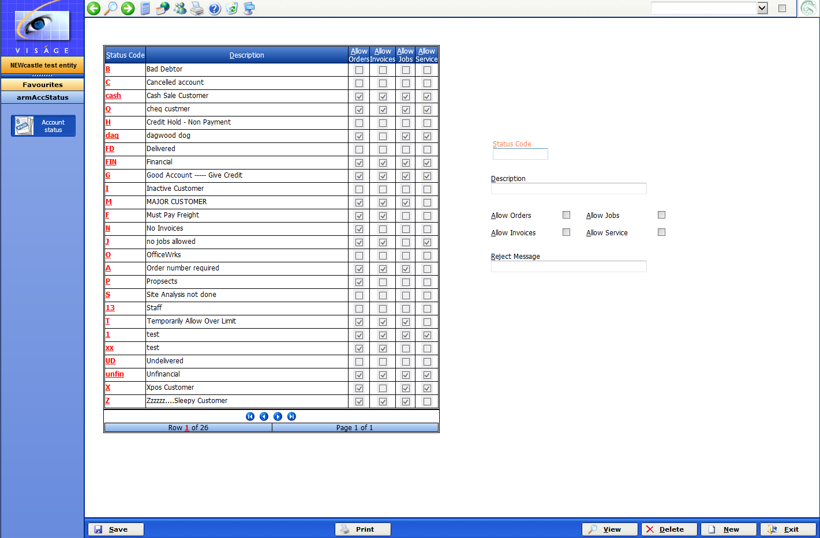

You can set the Allow options in this area to any combination you require.

- Status Code – This is a Code used to identify a particular Account Status that will be used to flag a Debtor account.

- Description – This is a meaningful extension for the Status Code used in the previous field.

- Allow Orders – Check if you want this Status Code to allow Customer orders to be raised. Leave this option unchecked if you want to inhibit the entry of orders for any customer that has this Account Status Code.

- Allow Jobs – Check if you want this Status Code to allow the entry and generation of Quotes and Jobs in the Job Costing system. Leave this option unchecked if you want to inhibit this feature. If you do not use the Job Costing system, leave this option unchecked.

- Allow Invoices - Check if you want this Status Code to allow Order Entry Invoices to be raised. Leave this option unchecked if you want to inhibit this feature.

- Allow Service - Check if you want this Status Code to allow Service Calls to be raised. Leave this option unchecked if you want to inhibit this feature. If you do not use the Service system, leave this option unchecked.

- Reject Message - This message will appear as a warning whenever a Customer is referenced that has this status code entered against them.
CUSTOMER FILE MAINTENANCE– Account Status

You can assign each Customer with a single Account Status Code via the Customer’s file process in the Accounts Receivable Maintenance Menu as you create each entry or after an entry has been created you can amend the details.

Navigate to the armCustomers - Customer File Maintenance process in the Accounts Receivable Maintenance Menu.

Enter the code for the Customer that you wish to amend here, or if you are creating a new entry, complete the details on this screen.

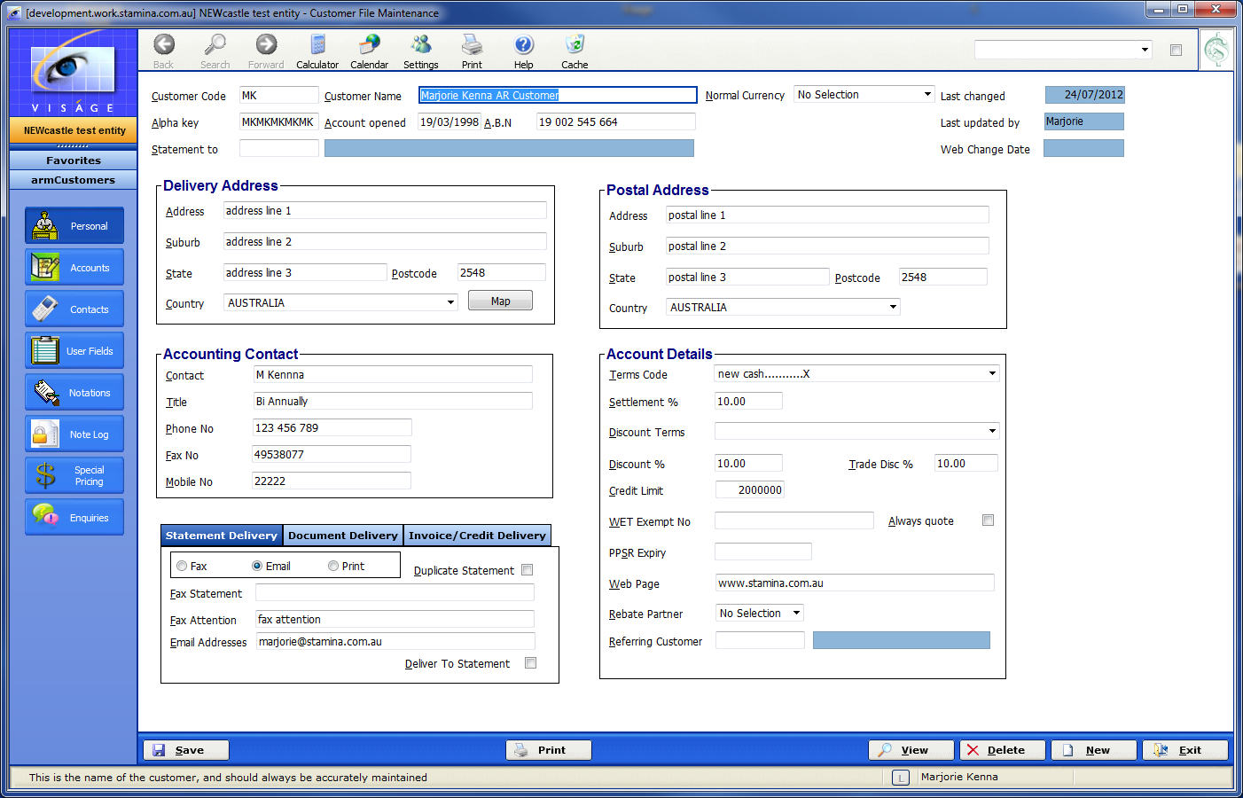

Click on the Accounts Button in the Navigation bar area on screen. If you are creating a ‘new’ Customer, complete the details on this screen.

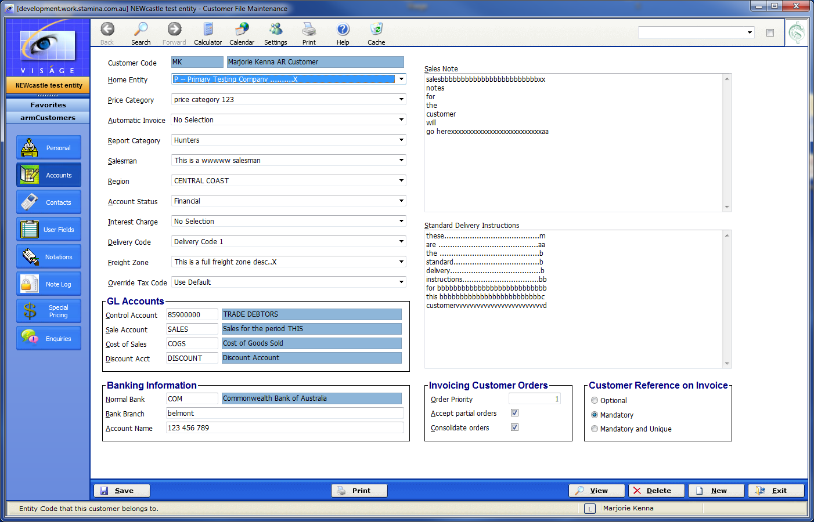
Select or change the Account Status code here

Account Status – Select the appropriate Account Status for this Customer.

Don’t forget to click on the Save button to save and changes for this entry.

Continue to enter further details if you are creating a new entry and click Save button to save changes.

This Customer will then be set in the system with the Account Status code you have selected here.

Click Exit to return to your original process.
CHANGE CUSTOMER ACCOUNT STATUS CODE

You can change the Account Status for a Customer from any process in the system where you can enter a Customer Code. A few examples are listed below.

Enquiry Screen of Debtors Enquiry

Navigate to the Debtors Enquiry process in the Accounts Receivable – Enquiries Menu.

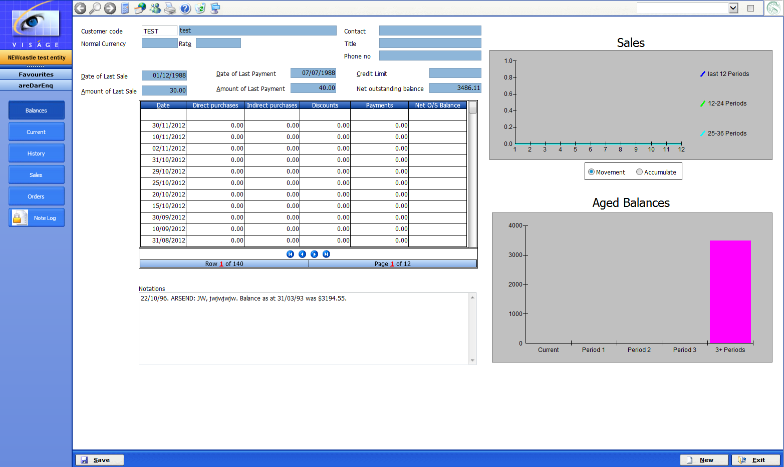

Cash Receipts Entry Screen

Navigate to the Cash Receipts process in the Accounts Receivable Transactions, Payments Menu

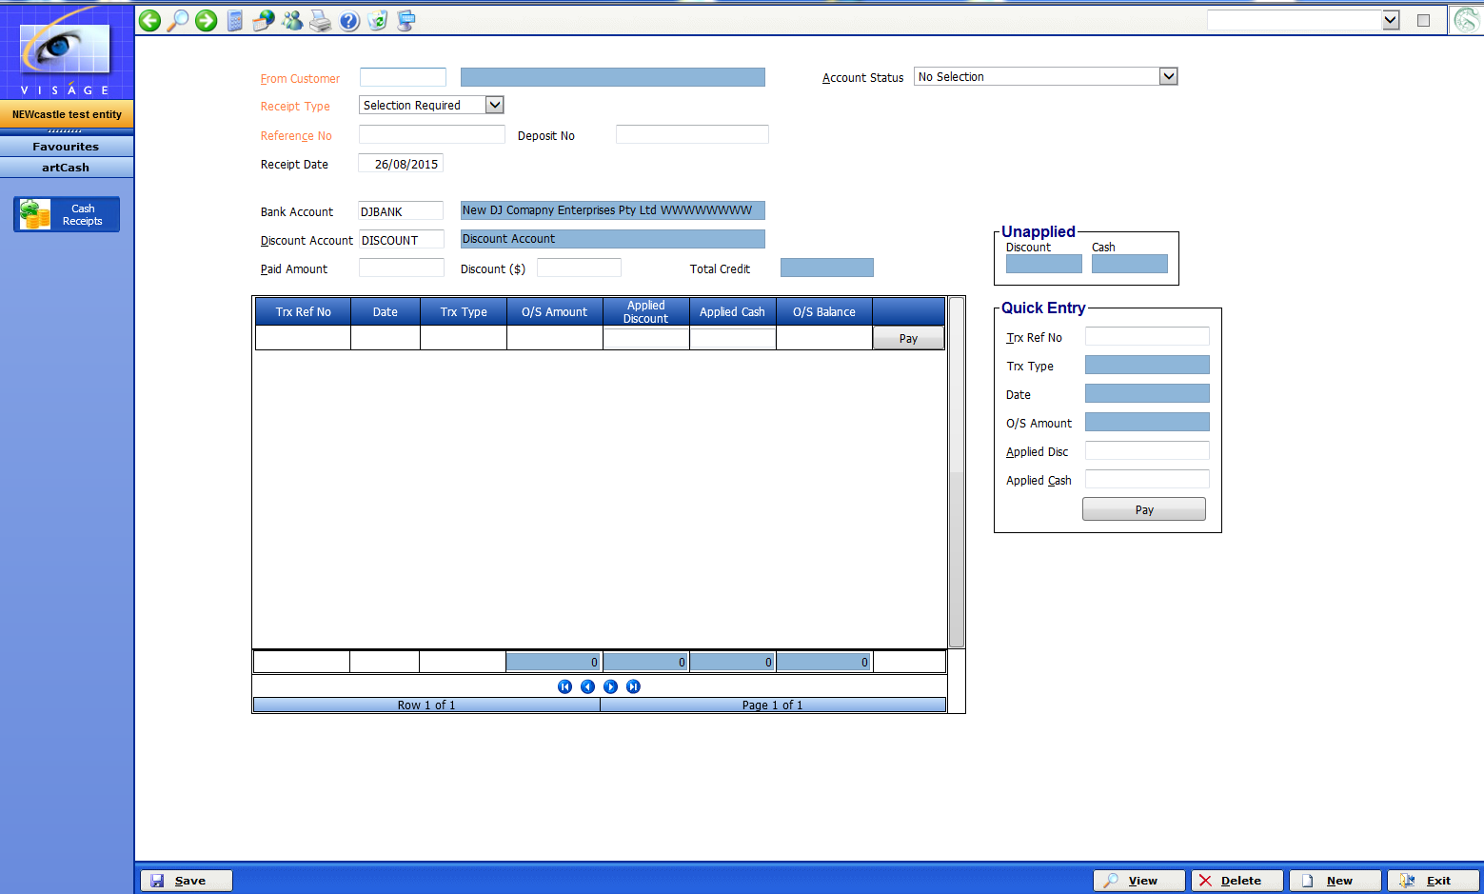

Steps to follow to change Account Status code:

- Position mouse pointer in the field that is referencing Customer Code. The field might be called:- From Customer/Deliver to etc depending on the process you are in.

- Right click with mouse and select Maintain option.

- You will then be taken to the Customer File Maintenance process.

- Enter the Customer Code you wish to change the Account Status for.

- Press Enter

- Details for the Customer will then be displayed on screen.

- Click on the Accounts button in the Navigation bar on screen

- Locate the Account Status option.

- Change the Account Status code to the code you want. Don’t forget to click Save.

If there is no valid Account Status Code available from the drop down list of options:

- Position mouse pointer in the Account Status field option
- Right click with mouse and select Maintain option.
- You will then be taken to the Account Status process, where you can then create a new Account Status entry.
- Save your work, and click Exit to return to the Customer File Maintenance process.
- Select the ‘new’ Account Status code you just created.
- Save your changes and exit.

