ACCOUNTS RECEIVABLE - APPLY PAYMENTS & CREDITS

A credit can occur from:

- A payment which has not been fully applied or an overpayment has occurred.
- A credit has not been applied.
- A part payment has occurred and has not been applied.

The Debtors Enquiry – areDarEnq – Debtors Enquiry process provides the facility to apply an open or unapplied credit to specific Invoices or account adjustments.

If you want to quickly see which accounts have credits that need applying, navigate to the areMulti – Multi Customer Enquiry process.

This process is similar to a Debtors Trial Balance report (but on screen), and if you Tick the only show customers with unapplied credits – those customers that do not have unapplied credits will be excluded from the list.

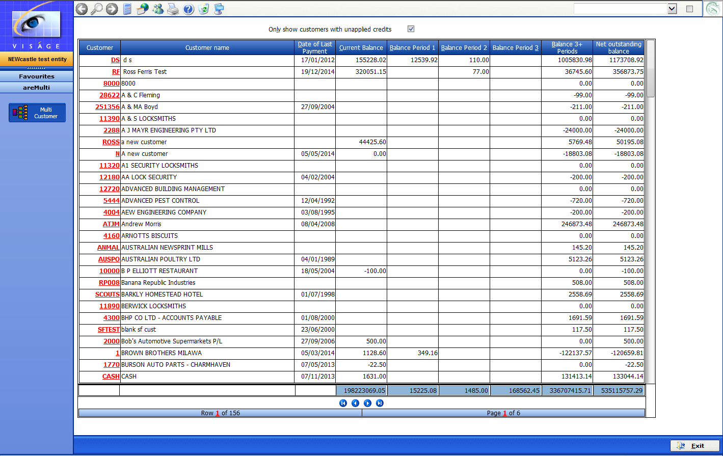

When Only show customers with unapplied credits option are ticked, the resulting list is reduced to exclude customers that do not have unapplied credits.

You can then choose to apply credits for each customer

- By clicking on the relevant Customer Code eg. CASH
You are taken to the areDarEnq - Debtors Enquiry process Cash Customer

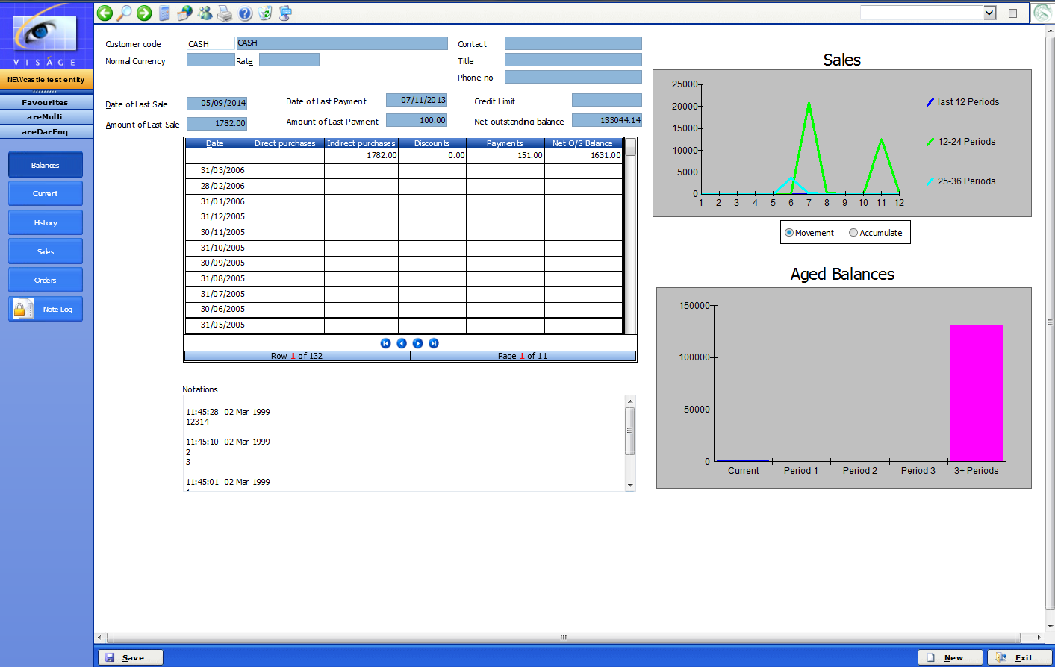

Click Current button to view Transactions for Current period.

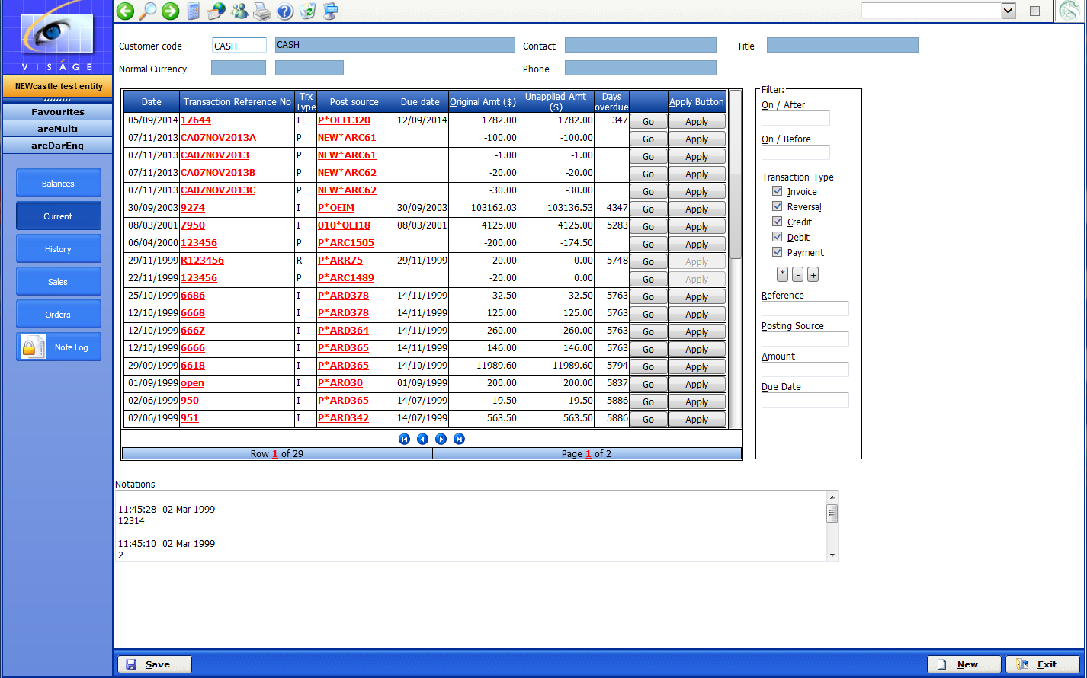

- Locate the unapplied Credit in the Table

- Click on the Apply button, where a list of Outstanding Transaction will display on screen for the nominated customer.

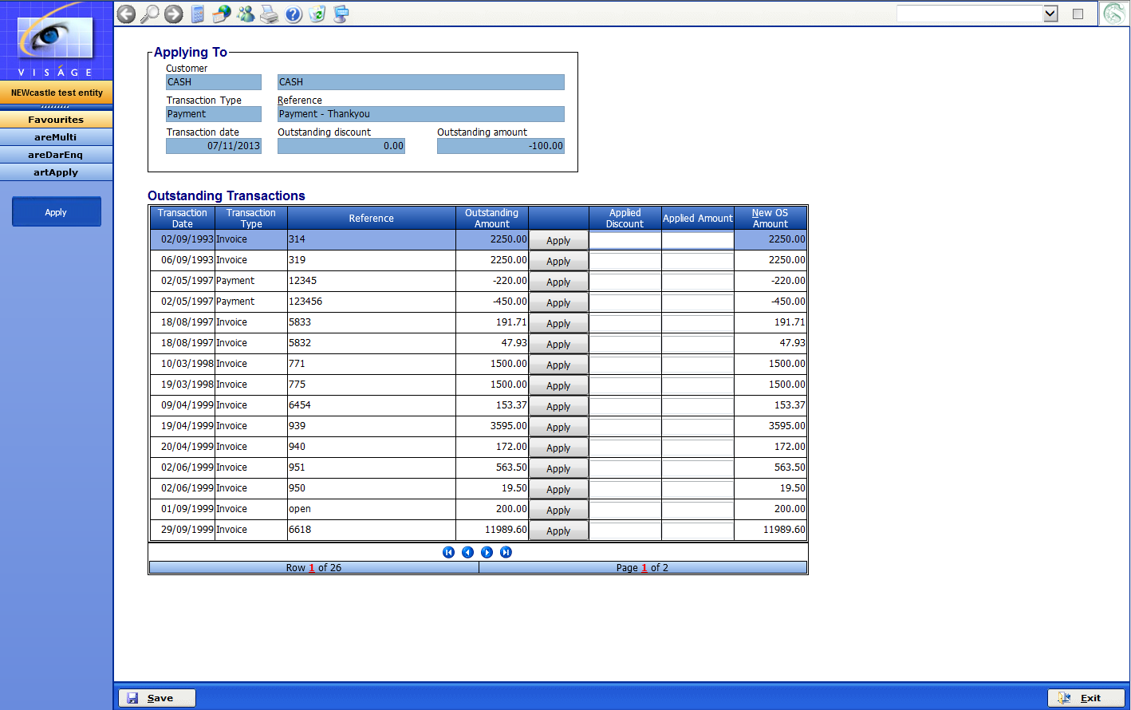

- Click on the row of the table where you want to apply this credit
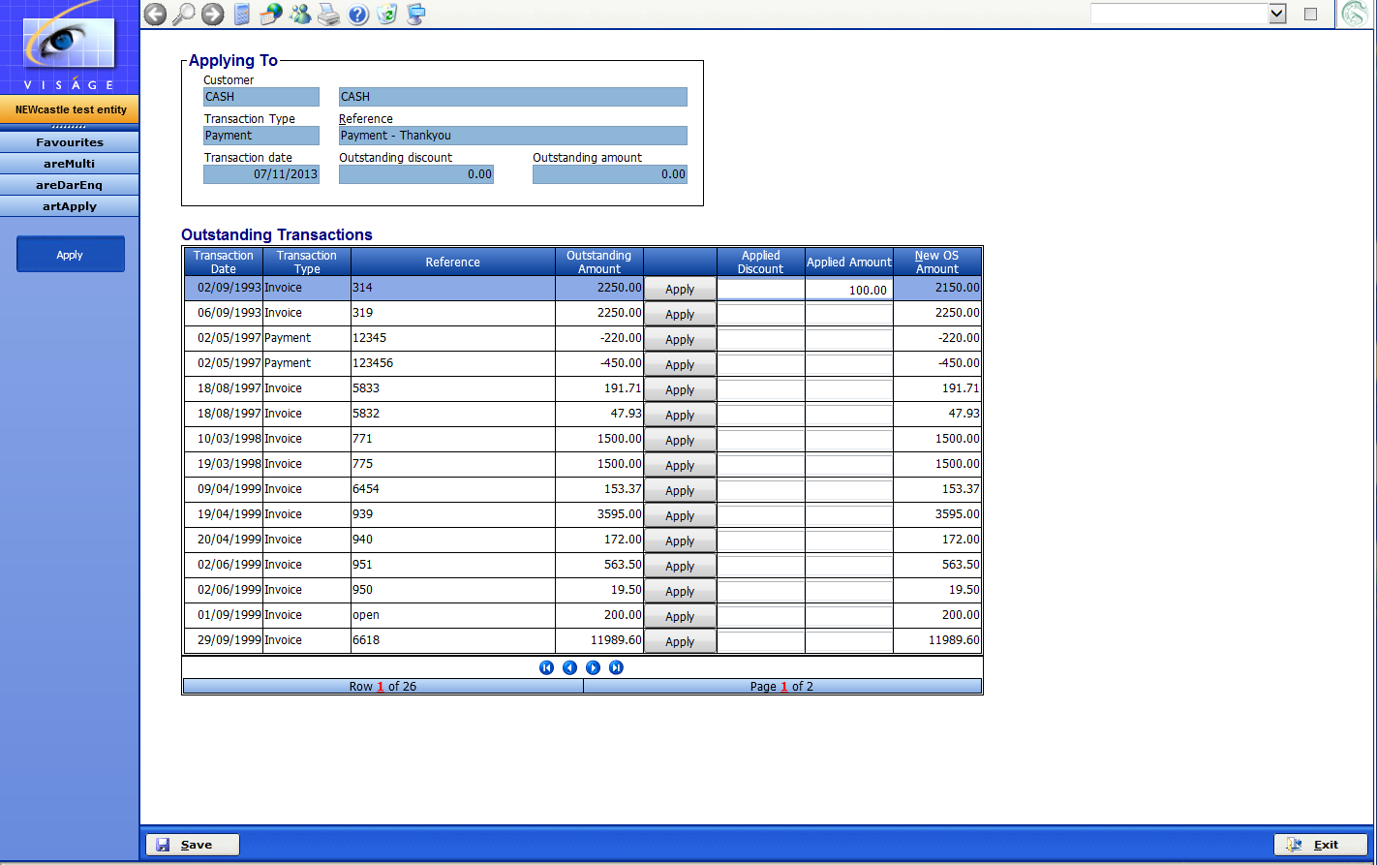

Click Save and you will be returned to the Current screen for the Debtor Enquiry.

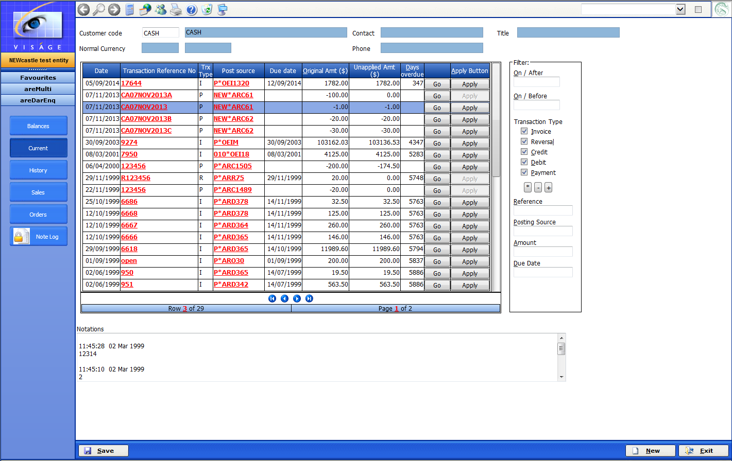

Click Save and click Exit

You will then be returned to the areMulti – Multi Customer Enquiry screen where you can select another Customer to apply any credits on their account.

Or if you have finished applying credits click Exit.

EXAMPLE

DEBTORS ENQUIRY - BALANCES SCREEN

The Debtors Enquiry – Balances Screen provides a brief summary of the period sales, payments and balances relating to the nominated account.

Debtors Enquiry Screen showing a breakup of Monthly sales

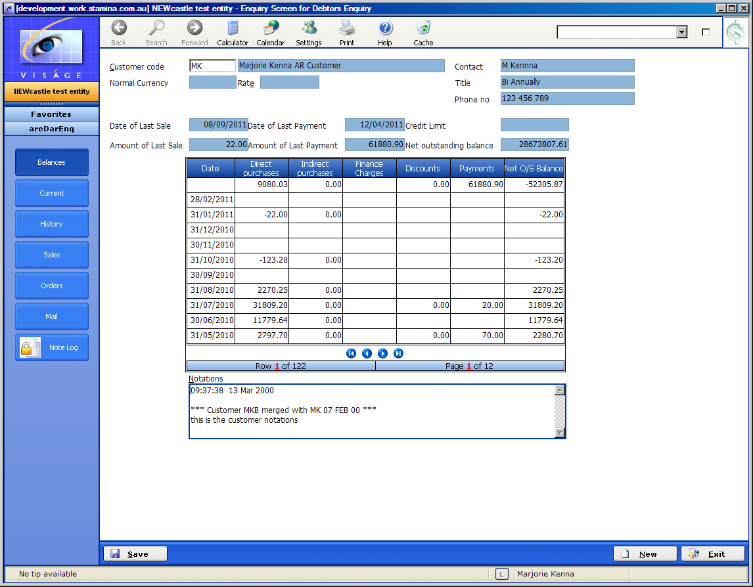

DEBTORS ENQUIRY - CURRENT SCREEN

The Current Screen lists all Transactions that remain outstanding.

Debtors Enquiry Screen showing Current Transactions

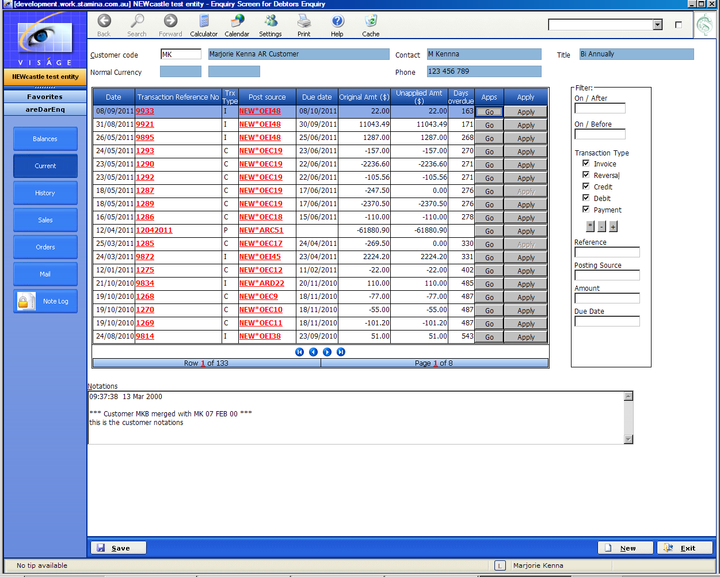

From this screen you can apply an open or unapplied credit to specific Invoices or account adjustments.

If a Transaction has 0.00 appearing in the Unapplied Amt ($) column the Apply button is not available. Only transactions with an unapplied amount outstanding are available to apply to specific invoices or account adjustment.

List of Current Transactions for nominated Customer
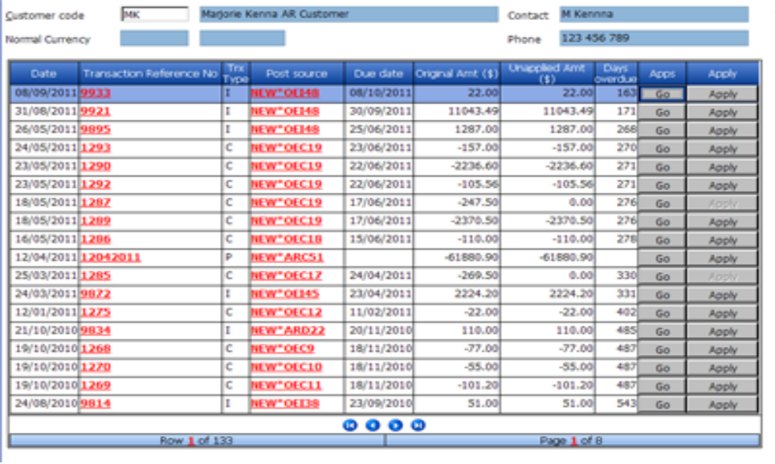
To apply the Transaction Reference No 1293

- Click on the Apply button in the Table row for the nominated transaction

The following screen will then appear where a list of the Current Transactions for the nominated customer will be displayed.

List of Current Transactions for nominated Customer
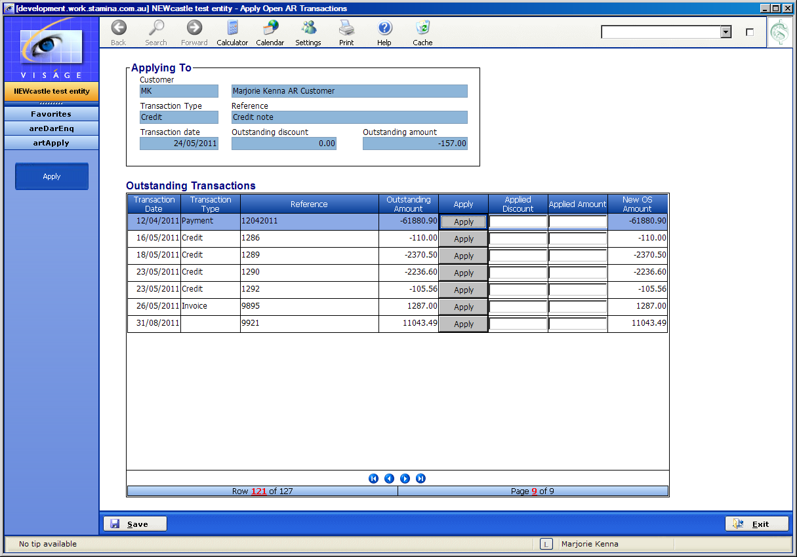

- Click on the Apply button in the Table row for the Transaction where you want to apply this Credit Transaction.

The amount of the Credit Transaction eg. $157.00 will be displayed in the Applied Amount column.

If you wish to apply 57.00 to this transaction and apply the remaining 100.00 to another transaction, you would position the cursor in the Table row where you wanted to apply the 57.00. You would then physically enter 57.00 in the Applied Amount column, press enter or click Apply button. Position the cursor in the Table row where the remaining amount will be applied and physically enter 100.00, press enter or click Apply button

The New OS Amount column will change be reduced by the amount of the application.

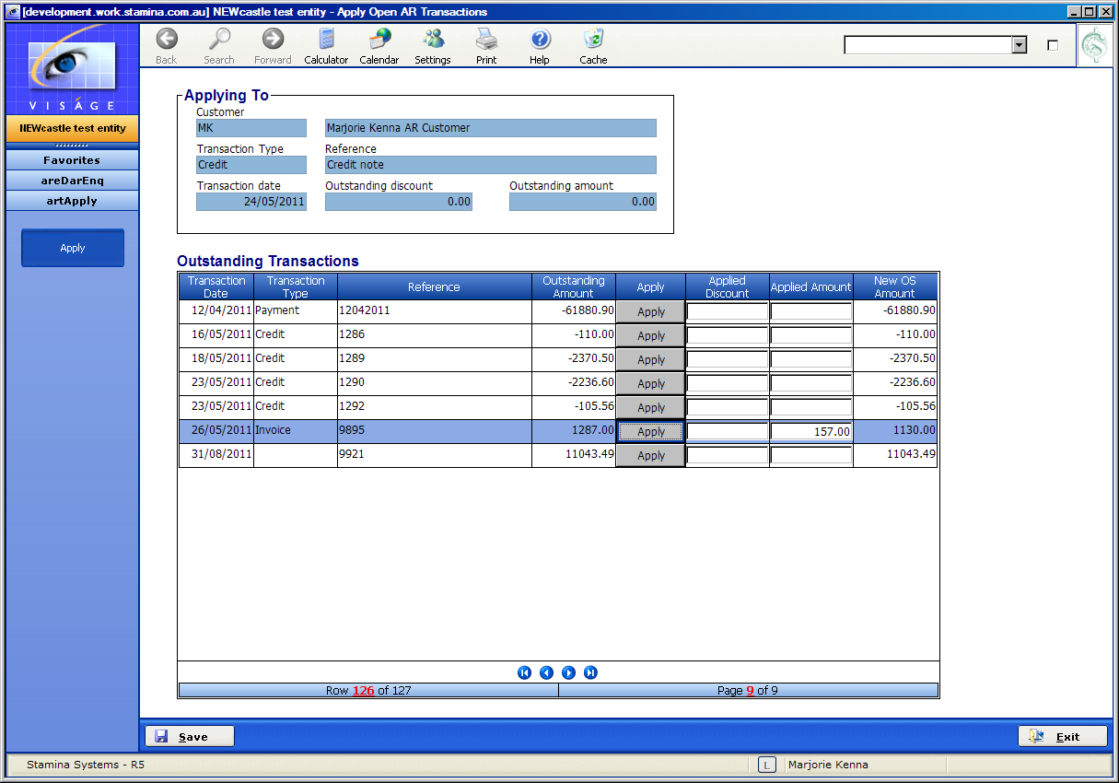

Click Save Button and you will be returned to the Current Transactions screen where the Credit Transaction 1293 now has 0.00 Unapplied Amt $ column and the Transaction Ref 9895, where we applied the Credit Transaction now has an Unapplied Amt $ showing 1130.00.

Current Transactions screen

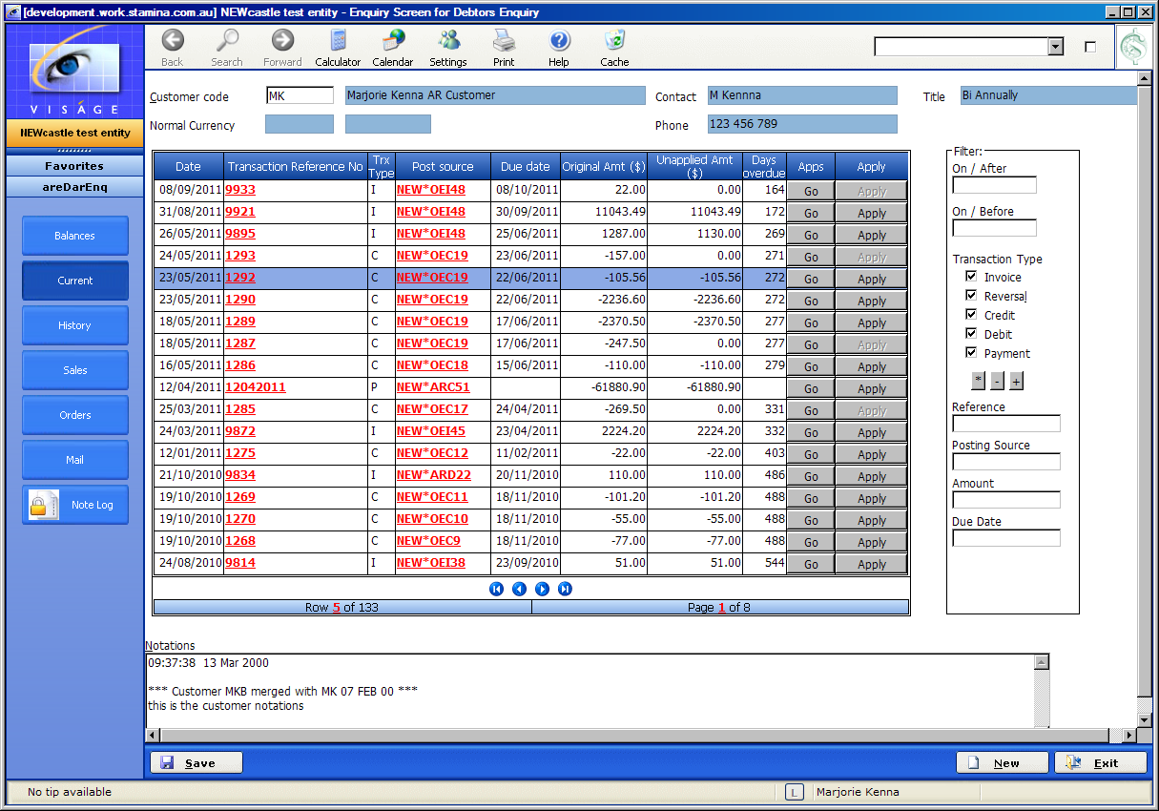

You can continue to apply transactions by selecting the Transaction Reference No with a Credit amount appearing in the Unapplied Amt ($) column , click on Apply button and then select a Debit type transaction to Apply against the Credit Transaction.

VIEW APPLICATIONS

If you wish to check how/where a particular transaction has been applied ie. 0.00 appears in the Unapplied Amt ($) column

- Navigate to the Debtors Enquiry Screen.
- Enter the Customer Code.
- Click on the Current or History Button.
- Locate the relevant transaction in the list of Transactions.
- Click on the Go Button appearing in the Apps/Applications column
- A screen similar to the following will appear where you can see that in this example, Credit Reference 1293 for $ 157.00 has been applied against Invoice Reference No 9895.

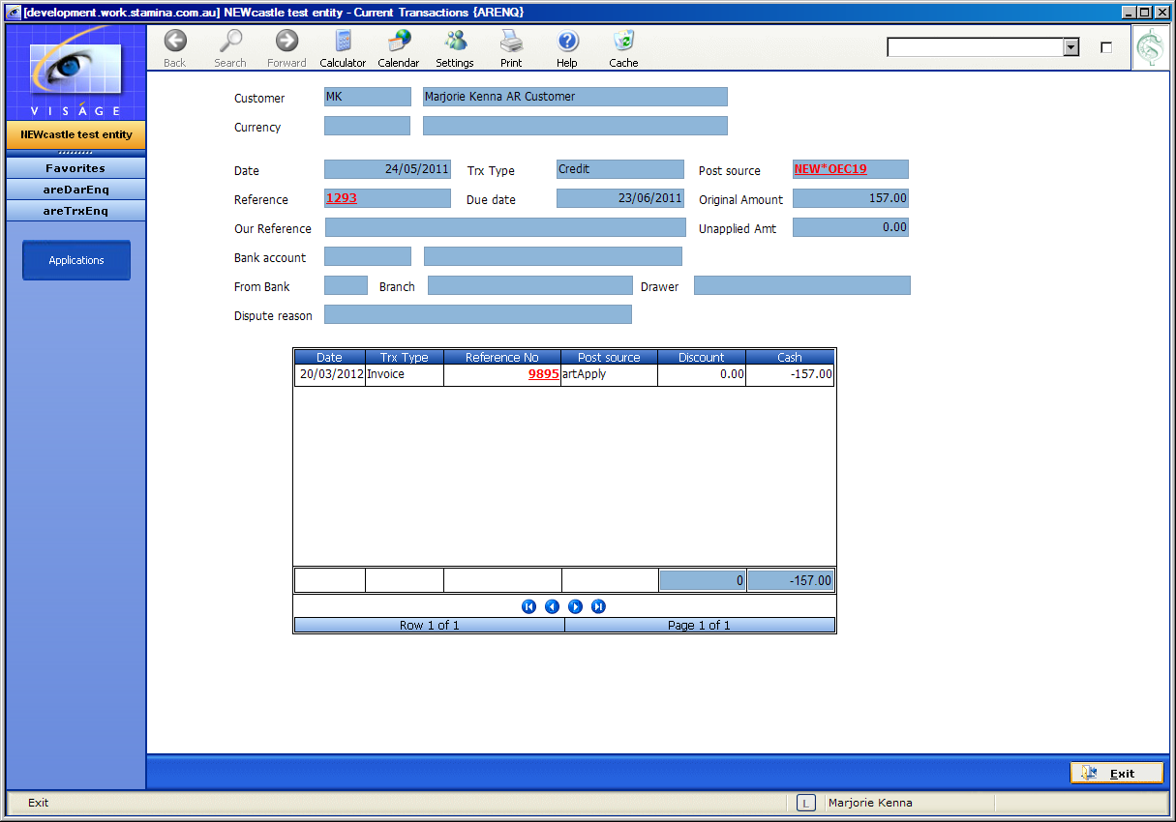

Click Exit to Return to Current Debtors Enquiry Screen.

VIEW DOCUMENT SOURCE
To view the actual document source eg. View the Invoice or the Credit etc.

- Navigate to the Debtors Enquiry Screen.
- Enter the Customer Code.
- Click on the Current or History Button.
- Locate the particular transaction reference no in the Table list of transaction
- Click on the red number in the column – Transaction Reference No. eg. In this example click on 9809 in the Transaction Reference No column and a screen similar to below will appear.

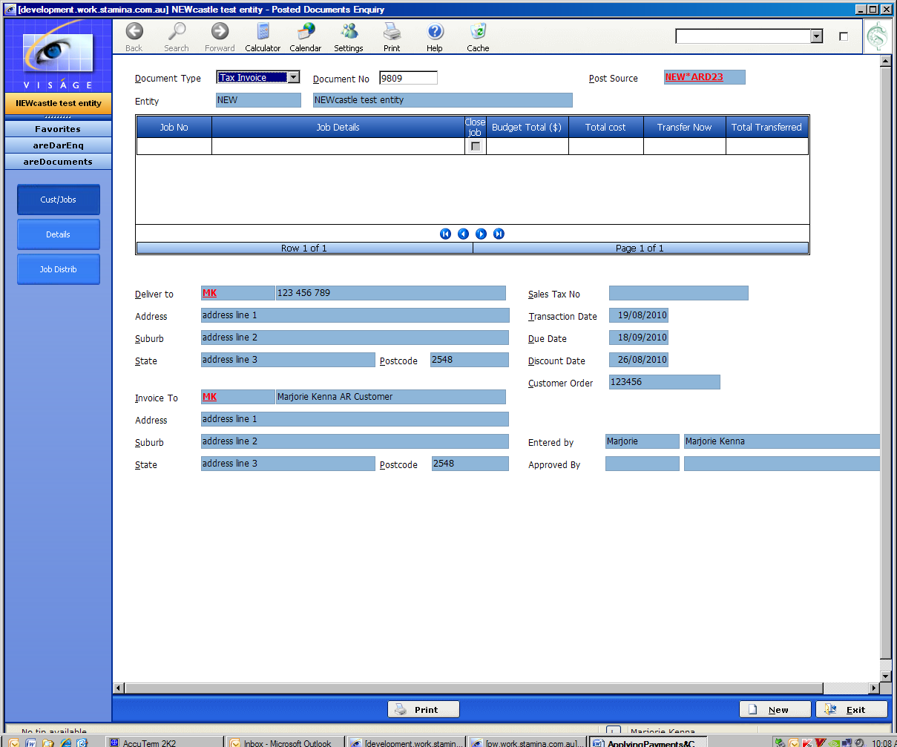

Click on the Details and the Job Distrib button from this process to view the information for this Invoice.

Click Exit button to return to the Debtors Enquiry process or Click Print button if you want to print a copy of this Document/Invoice.

