CREATE NEW CUSTOMERS

To create a new Customer entry, navigate to the Accounts Receivable Maintenance Menu, Select Customer File or enter armCustomers in the Quick Access selection option.

Fields indicated as mandatory (Red Label, eg. Customer Name, Terms Code etc) require data input, where other fields indicated with a Black label eg. Statement to, Address, Suburb etc do not necessarily require data input, but these fields can be changed if required.
To access Help for all fields – position cursor in the field and press F1 or click on 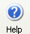Help button.

To access Search for fields that have Search available – position cursor in the field, Click on 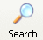Search Button, or right click and select Search option.

PERSONAL

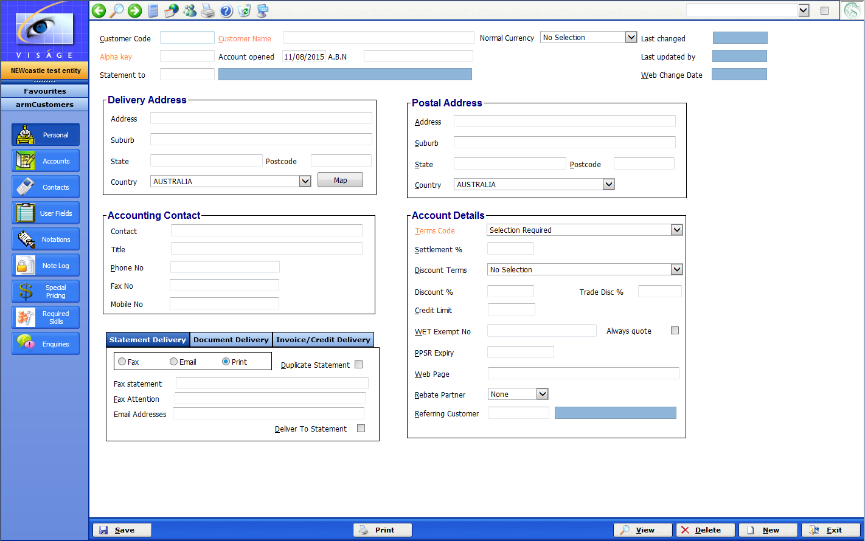

- Customer Code – This is a unique code that will be used to identify this Customer throughout the system.
- Customer Name – This is the detailed name of the Customer and should always be correct.
- Alpha Key –This is an alphabetic key that can be used when sort the Customer records.
- Account Opened – Enter the actual date the account was opened. It will default to today’s date.
- A.B.N – This is the Customer’s ABN here, in the format of xx xxx xxx xxx.
- Statement to – If the statement is to go to an ‘other’ customer, enter the customer code here, or else leave this field blank.

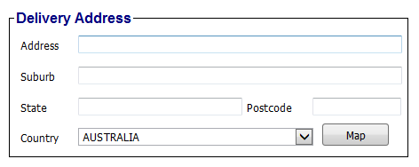
Delivery Address
- Address – This is the delivery address for this customer.
- Suburb – This is the delivery address – Suburb for this customer.
- State – This is the delivery address – State for this customer.
- Postcode – This is the delivery address – Postcode for this customer.
- Country – This is the delivery address – Country for this customer.

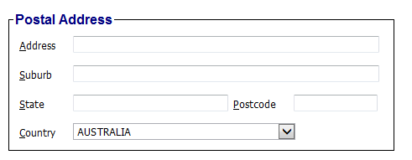
Postal Address
- Address – This is the postal address for this customer
- Suburb – This is the postal address – Suburb for this customer.
- State – This is the postal address – State for this customer.
- Postcode – This is the postal address – Postcode for this customer.
- Country – This is the postal address – Country for this customer.

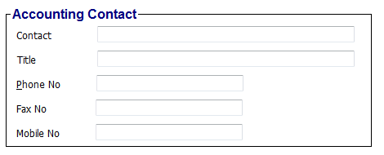
Accounting Contact
- Contact - This is the name of the person who should be contacted in relation to this account.
- Title – This is the title of the contact person. This can be left blank.
- Phone No – This is the Customer’s phone number.
- Fax No – This is the Customer’s fax number.
- Mobile No – This is the Customer’s mobile contact number.

Account Details
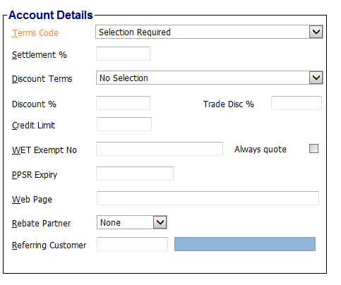
- Terms Code – This is code used to identify specific trading or payment terms to the system. Select the appropriate code here. Additional Terms Codes can be created via the ssmTermsCode process.
- Settlement % - This is the discount percentage that would normally be given to this customer, if payment is received before the date indicated by their payment terms. If this does not apply, leave this field blank.
- Discount Terms – This uniquely identifies specific trading or payment terms to the system.
- Discount % - This is the normal discount percentage given to this customer if payment is received before the date indicated by their payment terms.
- Trade Disc % - This is the normal trade discount percentage given to this customer regardless of when payment is made.
- Credit Limit – This is the amount of credit that you have given this customer.
- WET Exemption No – This is the number for this customer if they quote a Wine Equilisation Tax Exemption number. If there is no number leave this field blank.
- Always Quote – Click for Yes or leave un-ticked for No.
- PPSR Expiry –
- Web Page – Enter the customer’s web address if they have one. Leave blank if they do not have a web site.
- Rebate Partner – Select for Rebate Partner, either Local or National. Leave selection set to none if this does not apply to this customer.
- Referring Customer – If this customer has been referred to you from an existing customer, enter that referring customer’s code here, or else leave this field blank.

Statement Delivery
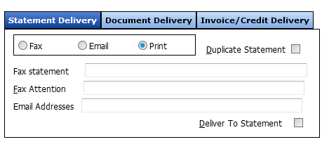
The options selected here indicate how the customer will receive Statements produced from the system
- Fax – Select this option if you want to fax Statements to this customer.
- Email – Select this option if you want to email Statements to this customer.
- Print – Select this option if you want to print Statements for this customer.

- Fax Statement – If you have selected to Fax statements to this customer, enter the fax number to be used here.
- Fax Attention – This can be the person responsible for receiving the statements from you.
- Email Address – Enter email address/addresses for the customer where the Statement will be delivered to.
- Deliver to Statement – Check this option to produce a separate STATEMENT for each ‘deliver to customer’ associated with this account.
- Duplicate Statement – Select this option if you wish to automatically print a statement to a printer. You may have selected to email statements to this customer, if you select this option the statement will be emailed as well as a copy printed to your printer.

Document Delivery
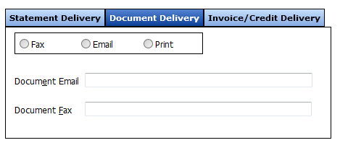
The options selected here indicate how the customer will receive AR documents produced from the system.

- Fax – Select this option if you want to fax AR Documents to this customer.
- Email – Select this option if you want to email AR Documents to this customer.
- Print – Select this option if you want to print AR Documents for this customer.
- Document Email – Enter the email address/addresses that will be used to deliver AR Documents for this customer. Multiple email addresses may be entered. Each address is separated by “;” eg. account@zxx.com.au;manager@zxx.com.au
- Document Fax – Enter the fax number that will be used to deliver AR Documents to this customer.

Invoice/Credit Delivery
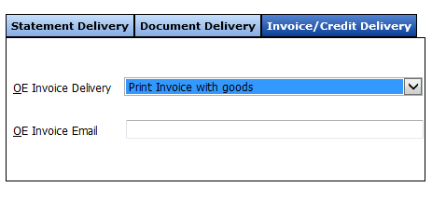
The options selected here indicate how the customer will receive Order Entry Invoices and Credits delivered to them from the system.
- OE Invoice Delivery – Options selected here indicate how this customer would like Invoice/s from the OE system delivered.
- OE Invoice Email – Enter the email address for delivery of OE Invoices for this customer. Multiple email addresses may be entered. Each address is separated by “;” eg. account@zxx.com.au;manager@zxx.com.au

ACCOUNTS

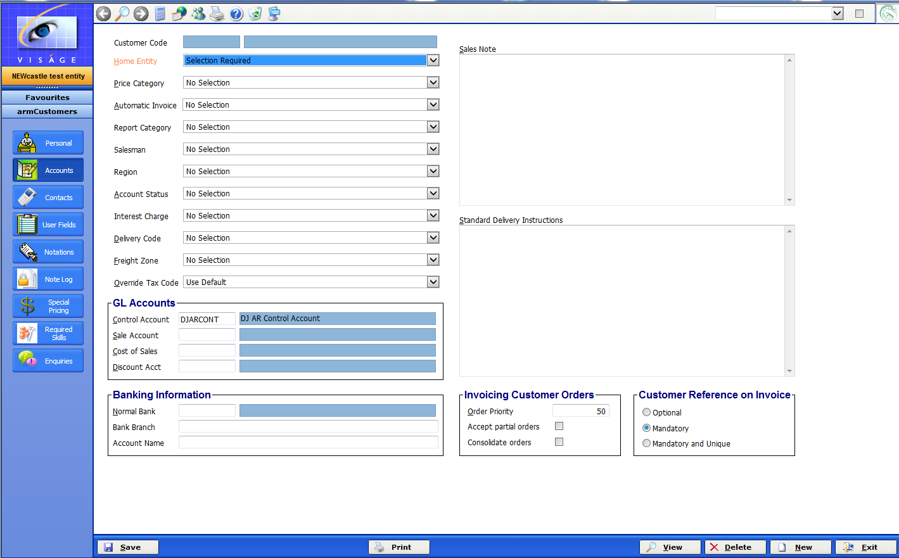

- Home Entity – Select the Entity Code from the drop down list that this Customer belongs to.
- Price Category – This field is used to group together those customers that might be given particular prices for items, regardless of the normal selling price. Price Categories are maintained in the armPriceCat process.
- Automatic Invoice – if you raise invoices against jobs, you can specify a default invoicing rule to be applied to all jobs for this customer. If this does not apply to you, leave this field blank. Automatic Invoice rules are maintained in the armAutoInv process.
- Report Category – This field is used to group together customers of a particular type for the purposes of reporting. You might like to group together builders, painters, plumbers etc. Report Categories are maintained in the armCategory process.
- Salesman – This field identifies that Salesman that might be responsible for this account. Salesmen are maintained in the armSalesman process.
- Region – This field is used to group together customers which are from a particular geographic area for the purposes of reporting. Regions are maintained in the armRegion process.
- Account Status – This field is used to flag the customer’s account. Eg. Overdue – pay now, account on stop, account not used. Account Status codes are maintained in the armAccStatus process.
- Interest Charge – This field can be used to indicate the type of finance charge that should be applied to this account if the account is overdue. Interest charges are maintained in the armFinChg process.
- Delivery Code – This field is used to indicate the delivery code used by this customer. Delivery Codes are maintained in the ssmDelivCodes process.
- Freight Zone – This field can be used to determine where a customer may belong in a certain delivery code. Freight Zones are maintained in the armFreightZone process.
- Override Tax Code – Select a tax code here if you always want this customer to use a particular tax code. This is useful for export customers that do not attract GST.

GL Accounts
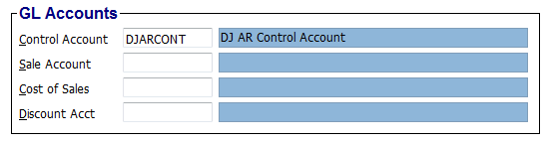
- Control Account – This is the Trade Debtors Control Account.
- Sale Account – This is the account that will be affected in the General Ledger when a sale or credit is posted to this Customer.
- Cost of Sales – This is the Cost of Sales General Ledger Account.
- Discount Acct – This is the Discount Account from the Chart of Accounts.

Banking Information
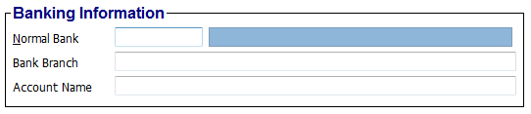
- Normal Bank – This field refers to the Financial Institution code that relates to this customers bank. Financial Institutions are maintained in the brmFinancialInstit process.
- Bank Branch – This field refers to the Branch relating to the Financial Institution for this customer.
- Account Name – This is the name that appears on a cheque from this customer

- Sales Note - A reminder note that will appear on screen when sales are entered for this customer may be entered here. If you do not require this, leave this field blank.

- Standard Delivery Instructions – This field can be used to record any standard delivery instructions for ALL deliveries for this Customer. If this customer does not have any standard delivery instructions, leave this field blank.

Invoicing Customer Orders
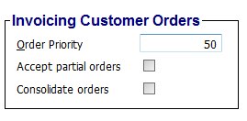
- Order Priority – This field can be used to record the default order priority that will be used for any orders entered for this customer.
- Accept Partial Orders – This field serves as an option with generating Order Entry Invoices from Customer Orders. Where the Yes option is selected Invoices will be generated from partly filled as well as completely filled customer orders.

Where the No option is selected here, Invoices will not be generated from Customer Orders until the Order has been completely filled.
- Consolidate Orders - This field serves as an option with generating Order Entry Invoices from Customer Orders.

Where the Yes option is selected here, when you are generating invoices from customer orders that belong to the same customer, the ‘allocated’ lines on those orders belonging to the same customer will be consolidated and transferred to ONE invoice only.

Where the No option is selected here, when you are generating invoices from customer orders that belong to the same customer, a SEPARATE invoice will be created for each order that has allocated lines on it.

Customer Reference on Invoice
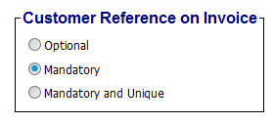
The choices made here will depend on what is entered in the Customer Ref field when creating an OE Invoice for this customer.
- Optional – This choice allows the Customer Reference field to be skipped if required.
- Mandatory – This choice makes it mandatory to make an entry in the Customer Ref field of Invoice.
- Mandatory and Unique – This choice makes it mandatory to make an entry in the Customer Ref field of Invoice AND the entry must be unique each time.

CONTACTS

You can maintain a list of people you might deal with in this organisation.

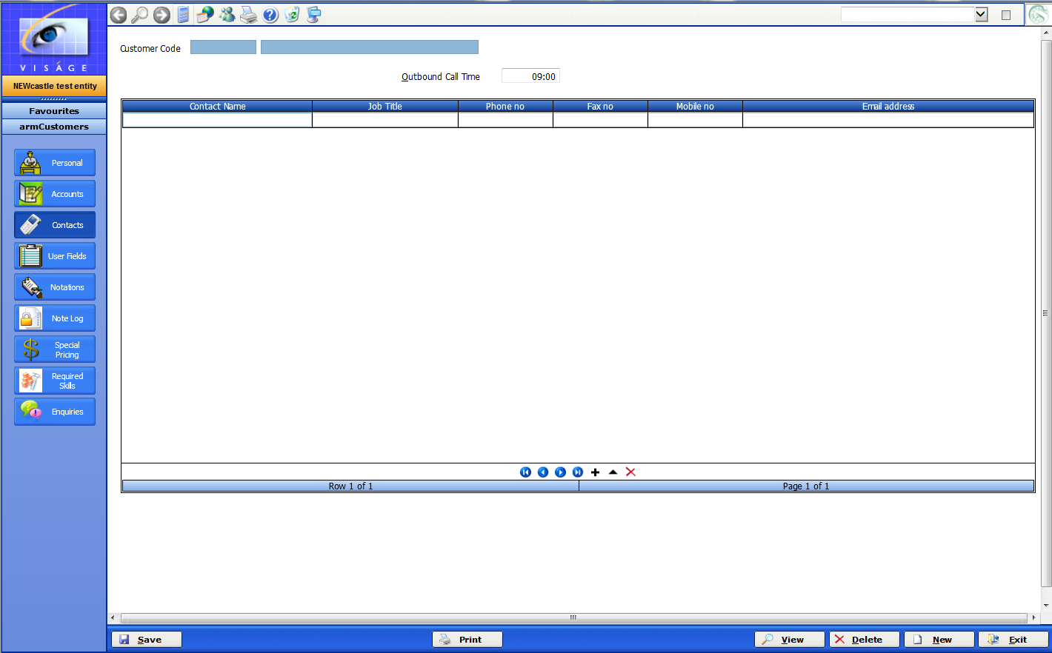

Use of this screen is optional.

- Contact Name – Enter as free form text for the Customer Contact Name.
- Job Title – Enter as free form text for the Job Title of the Contact Name just entered.
- Phone No – Enter as free form text for the Phone number of the Contact Name.
- Fax No – Enter as free form text the Fax Number of the Contact, if they have one.
- Mobile No – Enter as free form text the Mobile Number of the Contact.
- Email Address – Enter as free form text the email address of the Contact.

To add more contacts to this table, click on the + but add a row.

Continue to enter as many Contacts as you wish.
USER FIELDS

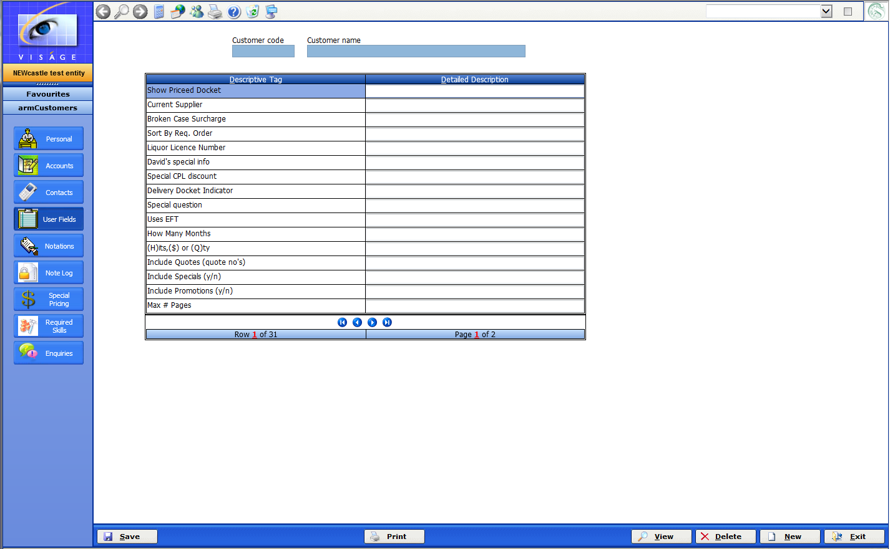

The Descriptive Tag entries are fields that allow you to store descriptive detail which are specific to your needs and are not catered for within the standards Accounts Receivable system. Descriptive Tag fields are maintained in the Accounts Receivable Maintenance Menu, Parameters process.

You can enter your responses to the descriptive tag fields in this screen.

Use of this screen is optional.

NOTATIONS

This screen allows you to keep in free form text any details you wish to keep in relation to this customer.

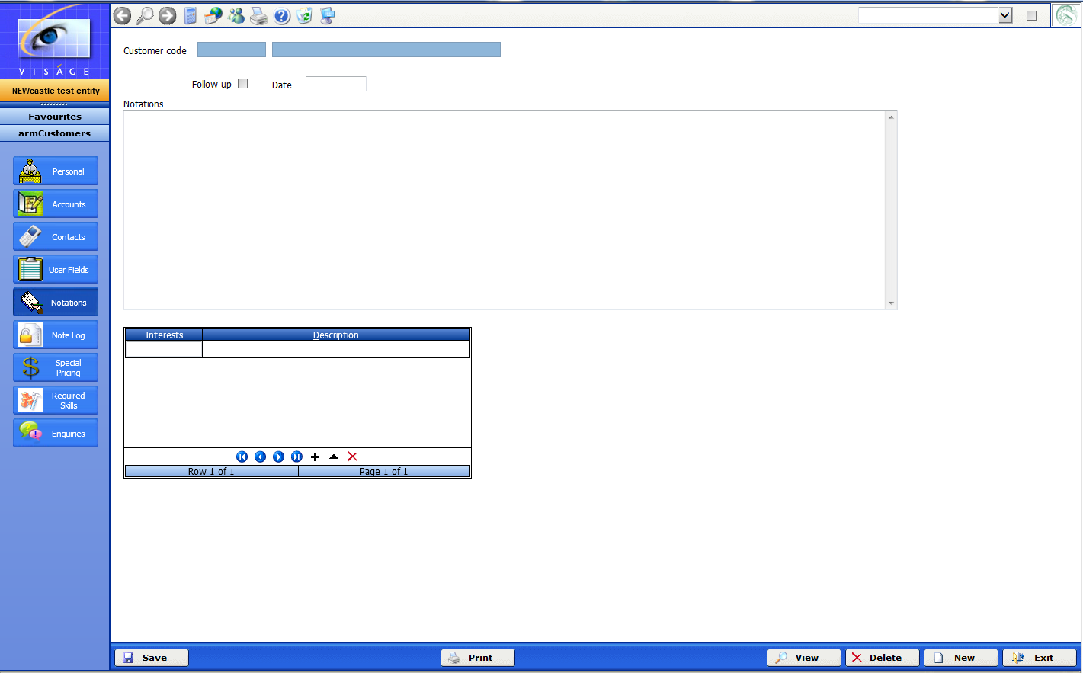
Use of this screen is optional.

- Follow up – Check this option for Yes. Leave unchecked for No. This can be used in conjunction with the next field – Date on which to follow up with this Customer.
- Date – Enter the date that you wish to be used if you have checked the previous field. If you do not wish to follow up and have leave the previous field blank, leave this field blank.
- Notations – Enter any free form text here for details that you wish to keep in relation to this customer.
- Interests – Represents an interest related to this Customer. It serves as a note or reference to be associated with this Customer. Interests are maintained in the armInterest process. Use of this field is entirely optional.

NOTE LOG

A valid customer record must be displayed before you can enter this screen.

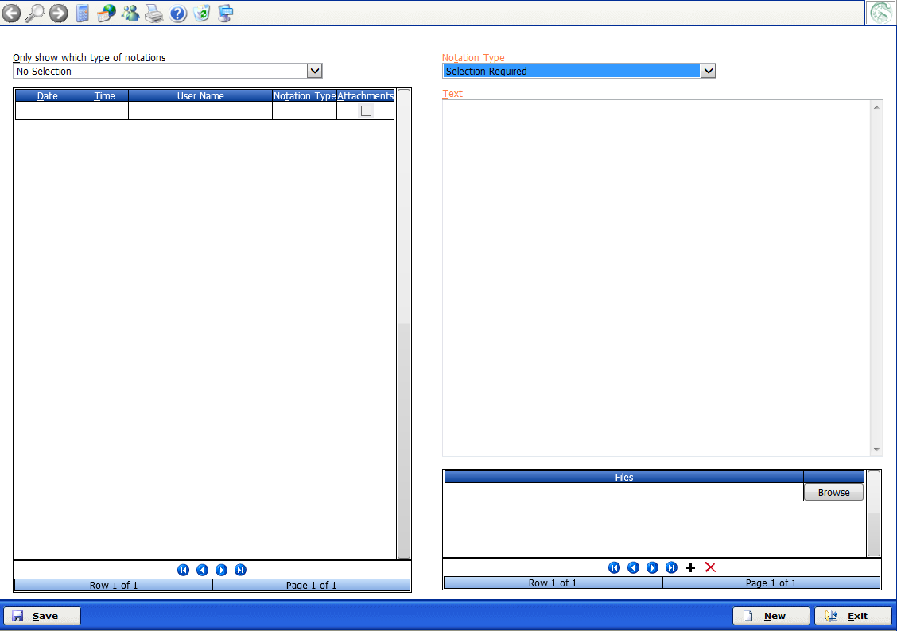

The use of this screen is optional but you may wish to record details of any contact you have with your customer. You may wish to keep track of each time:

- Your customer calls for copies of Invoices.
- You have to contact your customer requesting payment of their account.

If you have a signed Account Application form from your Customer, you may wish to store that on file.

You are free to create any notation type that is relevant to your information keeping requirements. Notation types are maintained in the ssmNoteType process.

Once information has been entered in this process, it cannot be changed or deleted.

To create a new entry

- Click on New Button located bottom right of screen.

- Notation Type – Make your selection from the list of options. You can set up Notation types in the ssmNoteType process. You may like to create a Notation type that will allow you to keep information on when you send out copies of Invoices to Customers or when you last contacted this Customer regarding outstanding balances on their account. The type of information you keep here can be as varied as you want.

- Text – Enter free form text into this field that will be relevant to the notation type selected.

Don’t forget to click Save button to save any new entries.

Click Exit button to return to Customer File Maintenance process.

To view an existing entry

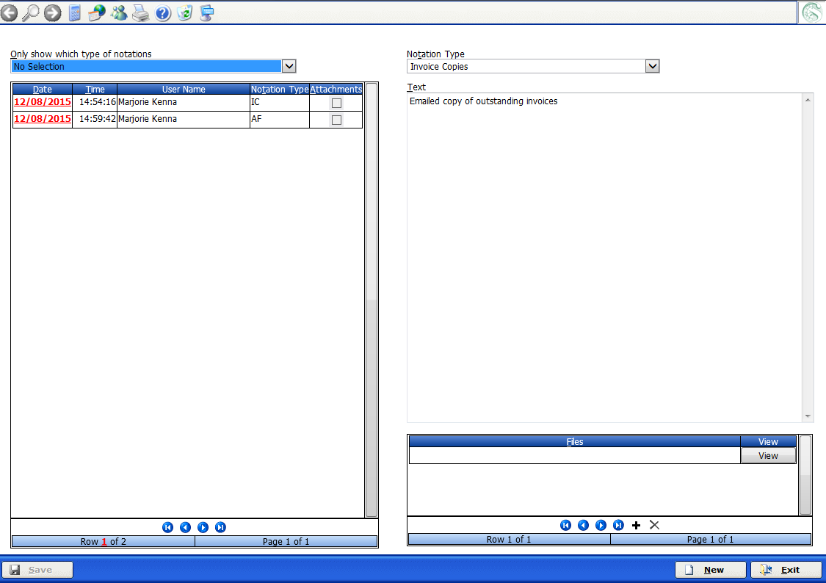

When you initially enter the Note Log process, all Notation entries will be displayed in the table left of screen. If you wish to only show certain types of notations you can –

- Make you selection from the only show which type of notations.

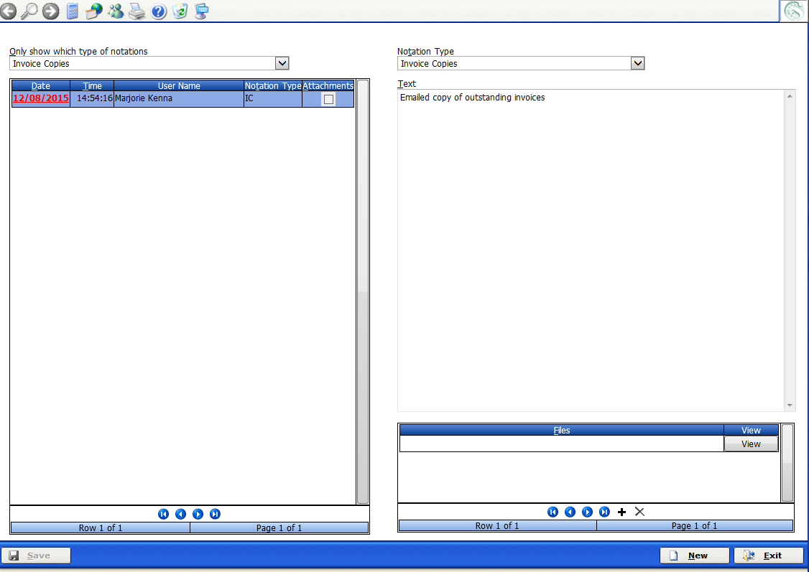

In this example we have selected the Type of Notation – Invoice Copies.

The table is then filtered to only show Notation types of Invoice Copies.

Any free form text that was recorded against this entry will be displayed

Information entered here cannot be deleted or changed. New entries can be added.

Exit will return to the Customer Master File process.
SPECIAL PRICING

It is most situations you can probably leave this screen blank. However if you have a situation where you have Suppliers that are offering special pricing to customers, you might like to utilise this screen.

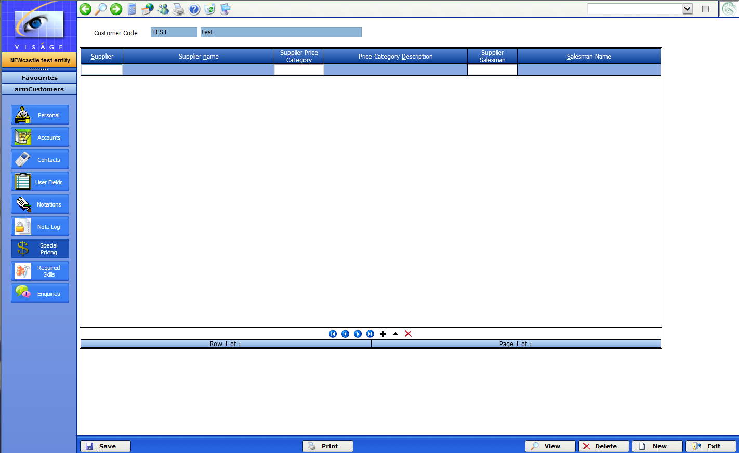

Utilising this screen will then save you having to set up special prices for each product for each supplier.

This screen can be used to indicate special pricing being offered by a nominated supplier for this customer.

- Supplier – Enter the nominated supplier that is offering special pricing for this Customer. The nominated supplier must already exist on the system.

- Supplier Price Category – Enter the special pricing category that applies when the customer purchases product from the indicated supplier.

- Supplier Salesman – This field is optional. You can nominate an internal sales rep assigned to this customer by the indicated supplier.

Don’t forget to click Save to save any entries.

REQUIRED SKILLS

You can enter skills required for employees to do work at this customer location, if this might be useful. If this is not likely to be relevant to this customer, you can leave this screen blank.

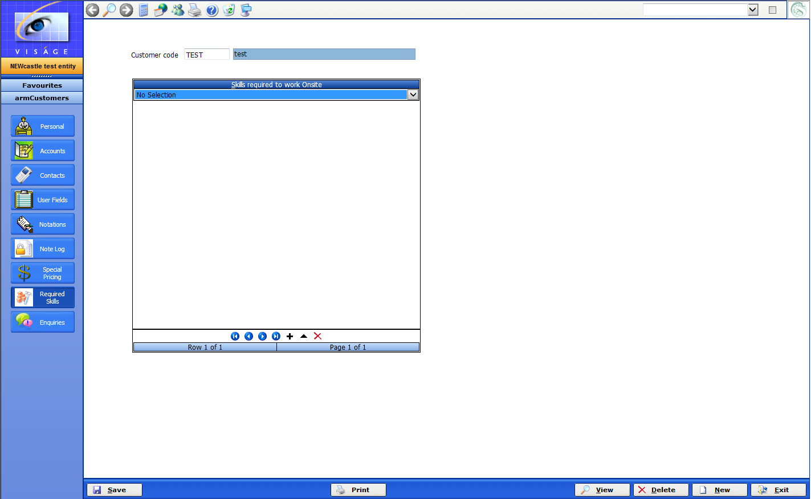

Click Save to record any changes.

Exit to return to the menu.

ENQUIRIES

The Enquiry screen allows you to perform an Account Enquiry on a selected Customer.

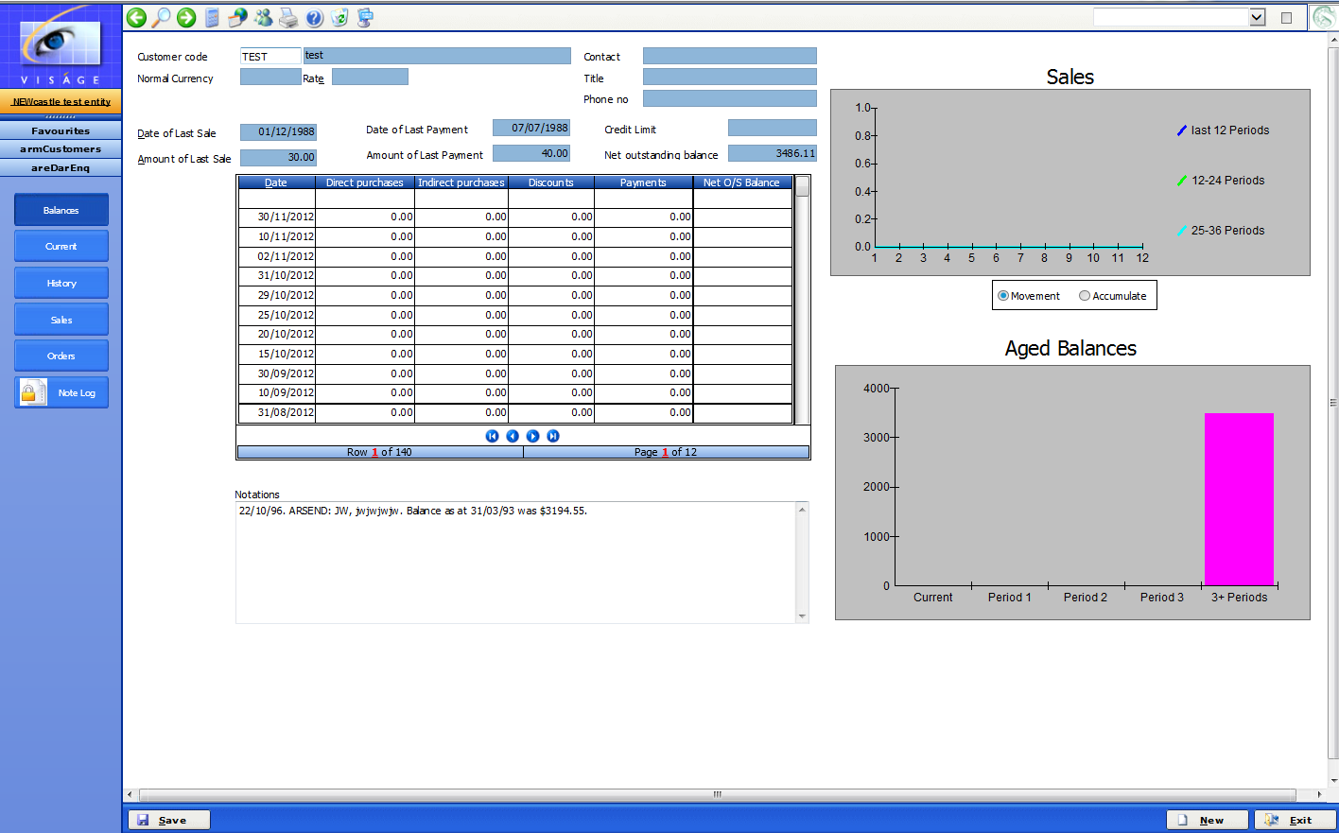

You will be able to view Summary, Current, History, Sales, Orders, Mail as well as any Notes from Note Log for this Customer.

Even though you are just creating a new Customer at this time, there will not be any details appearing in this Enquiry screen. After the Customer has been active for a period of time, you will then be able to view the Customer transactions from this screen.

