CREATE PURCHASE ORDERS

This process is used to establish and maintain your Order Book, allowing you to track the performance of your Suppliers and ensure that your Orders are fulfilled on time.

A single order may be placed against a Supplier for a single Entity, or the order may cover a number of locations. Each line of the order may have its own delivery date associated with it, allowing for staggered deliveries.

Amendments may be made to the order, allowing changes to order quantities, delivery dates etc. Additional lines may be added to the order or individual lines removed.

Fields indicated as mandatory (Red Label) require data input where the other fields indicated with a Black Label do not necessarily require input, but any default entries in any of these field can be changed if necessary.
To access Help for all fields – position cursor in the field and press F1 or click on 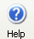Help button.

To access Search for fields that have Search available – position cursor in the field, Click on 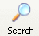Search Button, or right click and select Search option.

DETAILS SCREEN

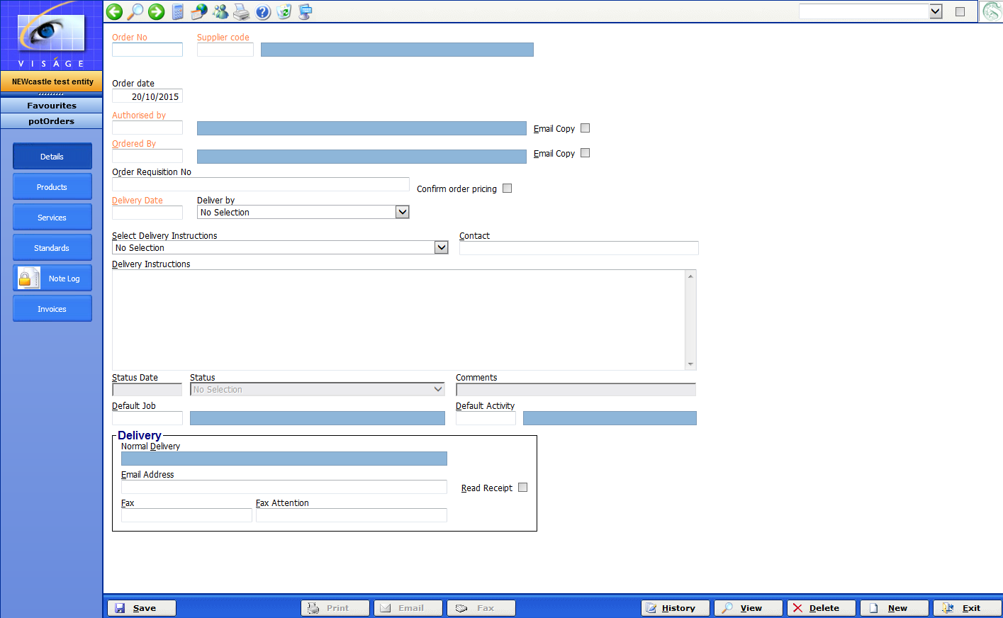

- Order No - This is automatically assigned when you Save the Order.

- Supplier Code – Enter the Supplier code that you are placing this Order against. Use search to locate valid Supplier codes.

- Order Date – This will default to today’s date. Change this if necessary.

- Authorised by – Enter a valid code for the person who has authorized this Order to be raised. Use Search to locate valid codes. This field can be left blank if you do not require an Authorised by here.

- Email Copy – Check this option if you wish to send a copy of the Purchase Order via email to the authorizer when it is printed, emailed or faxed.

- Ordered By – Enter a valid code for the person who has raised this Order. A valid code must be entered here. Use Search to locate valid codes. Note that if the person has an email address recorded against them, then when anything is received against this order, an email will be automatically generated to them.

- Email Copy – Check this option if you wish to send a copy of the Purchase Order via email to the person who raised this Order, when it is printed, emailed or faxed.

- Order Requisition No – If you have a manual requisition for this order, or internal reference of some kind, enter it here, otherwise leave this field blank.

- Confirm Order Pricing – Check for “Yes” indicating that the pricing on the order is confirmed or reliable. This enables the Goods Receipt Note processing to receive products into Inventory at a known cost and thus updating the average cost at this point. Otherwise, Products are received at the current average cost, with any adjustment awaiting the receipt of invoicing and being matched to the receipt note.

Updating the average cost upon receipt of goods by enabling confirmed order pricing allows subsequent stock movements to carry a more accurate costing. This can be critical when relying on costing booked to jobs, or profit at a transaction level (sales analysis figures). Cost adjustments handled otherwise are at a general ledger account level.

If pricing needs to be changed on the order in amend mode and this field has already been set to "Yes", you must answer "No" first, make the changes then answer "Yes" again.

This field is only accessible when the associated option is activated in Purchase Order Parameters - "Confirmed Order Pricing".

- Delivery Date – Enter date that the majority of items on this order are due to be delivered.

- Deliver by – Enter code for Delivery Method. eg. Fastway for Fastway Courier etc. Use Search to locate valid codes.

Any codes entered here must exist on the Maintenance Screen for Delivery Codes which is located in the System Menu – or right click with the mouse when the cursor is in this field and select the Maintenance option. You will then be taken direct to the Delivery Codes Maintenance screen where you can create a new code if necessary. Save the entry and exit to return to this process where you can then use the code just created.

- Delivery Instructions – These are instructions relating to the delivery of this order, which can be manually entered, OR selected from a library of standard instructions (below)

- Select Delivery Instructions – Select any delivery instructions that are applicable to this order. If there are no standard delivery instructions, leave this field blank.

Delivery Instructions used here must exist on the Delivery Instructions process which is located in the Purchase Order Maintenance Menu – or right click with the mouse, when the cursor is in this field and select the Maintenance option. You will then be taken direct to the Delivery Instructions process where you can create a new entry if necessary. Save the entry and exit to return to this process where you can then use the code just created.

- Contact – If you have a contact name with this Supplier, enter it here, otherwise leave this field blank.

- Status Date – This is the date that a status change was recorded against this order. You do not have to use this feature of updating statuses, but if you do by recording the correct date other people in the organization will understand how current the information is.

Status – You may optionally indicate the current status of this order. Any Status used here must exist on the Purchase Order status process which is located in the Purchase Order Maintenance Menu – or right click with the mouse when the cursor is in this field and select the Maintenance option. You will then be taken direct to the Status process where you can create a new entry if necessary. Save the entry and exit to return to this process where you can then use the code just created.

- Comments – any comments regarding the status of this order.

- Default Job – If you enter a Job Number here, when the goods and/or services are being allocated, this job number will be used as the default.

Delivery – The delivery options in this section will default with details already entered from the Order Delivery section of the Suppliers process in the Accounts Payable, Maintenance Menu. However, if required they can be changed here.

- Normal Delivery – This is a display only field and will default with details entered from the Delivery section of the Suppliers process in the Accounts Payable, Maintenance Menu.

- Email Address –This will default with details from delivery section of Supplier record. If there is no default here, you can enter an email address if you wish to send this Order via email. More than one email address can be entered, if required but each email address must be separated by ; eg. sales@supplier.com.au;sales1@supplier.com.au If you do not wish to send this order via email, leave this section.

- Read Receipt – If your supplier’s email software, supports sending read receipts, check this option if you wish to receive a read receipt from your supplier.

- Fax – Enter the fax number here, if you wish to fax this order.

- Fax Attention – Used to indicate who this order should be marked to the attention of.

PRODUCTS SCREEN

The Products Screen is where you enter the full details of Products that you are ordering from your supplier.

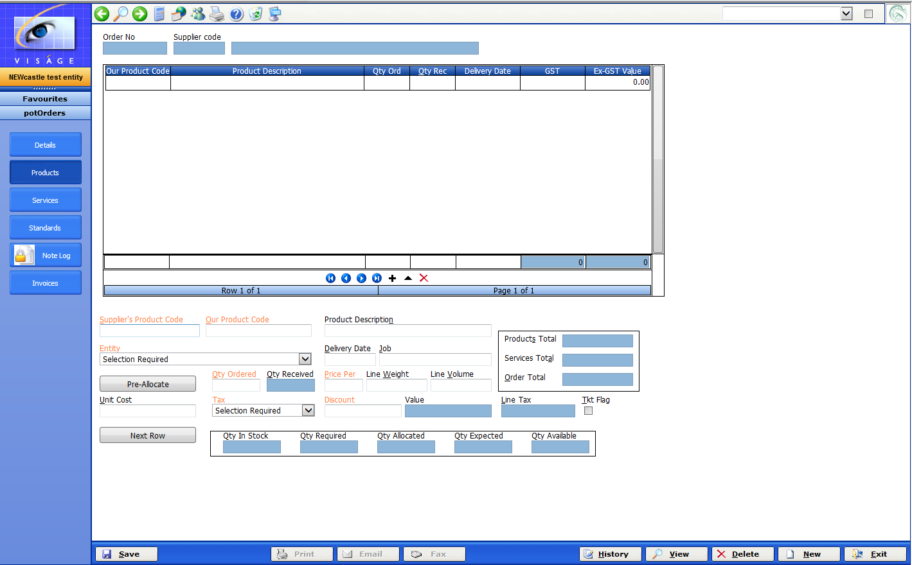

- Suppliers Product Code – Enter the code your Supplier uses to recognise this product. This code does not need to exist on your system, but if it has been used previously, the system will automatically retrieve your associated product code.

- Our Product Code – If the suppliers product code has not been previously entered, then enter the Product code you are ordering. This Product Code must exist as a valid product in your Product Maintenance process. Suppliers Produce Code and Our Product Code can be the same, and if not previously cross referenced, the system will make this default assumption

- Product Description – This will default with the Product Description set up for this product when it created in the Product Maintenance process.

- Entity – Will default to the current Entity you are in. If a different Entity is required change the selection.

- Delivery Date – Will default to the delivery date previously entered from the Details screen of this process, and if different you can enter the date this order line is expected to be delivered on.

- Job – If these goods to be used for a particular Job, you can enter that job number here. When the goods are received, the costs will be allocated to this job. If you do not utilise Jobs, you can leave this field blank.

- Pre Allocate – If you want to pre-allocate these Products click on the Pre Allocate button. A Window will pop up where you can apply the Purchased Products against existing Customer Orders / Jobs if you wish. If you do not wish to pre-allocate the ordered goods, do not click on this button.

- Qty Ordered – Enter the amount of this product that you are ordering.

- Price Per – Will default to what has been established on the product maintenance record, but when entering prices for products, you may receive a price for a certain quantity of the product that is different. In this case, enter the quantity in this field, and the cost for the quantity of products in the "Unit Cost" field.

- Unit Cost – Enter the Unit Cost of the product depending on the Price per in the previous field (defaults to values from product file)

- Tax – Select the code to use for this line if it is different to default on products file

- Discount – Leave blank if no discount applies here, or enter the discount percentage that applies at this point.

- Tkt Flag – Check this option if you wish to generate a stock ticket from this order line. If not, leave this option unticked.

Click on Next Row to add a new line to this Order.

Click on Save button if you are not entering any Services on this Purchase Order. A Purchase Order Number will then be created.

Click on Print or Email or Fax Button to submit Order to your Supplier.
SERVICES SCREEN

As part of this Order you might be ordering a Service. If you do not use Services, leave this screen blank.

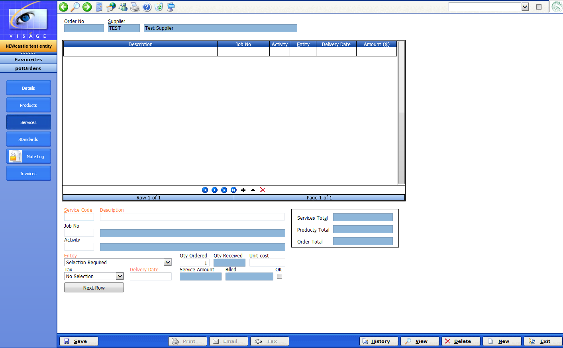

A Service could be spray painting, changing a light bulb, special buy in products for a job, subcontracted labour, equipment hire etc.

- Service Code – Enter the unique Service Code here. Service Codes must exist in the system, or they can be created by positioning cursor in this field. Right click with the Mouse. Select Maintenance option and you will be taken to the Maintain Service Codes Process. Enter the Service Code Details here. Save the entry and you will be returned to this screen, where you can then use this code.

- Description – You should enter a detailed description to describe the goods or services being referenced here.

- Job No – If this Service Code is to be applied to a particular Job Number, enter that Job here, or use Search to locate Valid Job numbers to use here, or leave this field blank if this service is not to be applied to a Job.

- Activity – Enter the Activity relating to the Job that this Service Expense will be allocated against. This field will only be asked if a Job Number is entered in the previous field.

- Entity – Will default to the current Entity you are in, and can be changed to a different Entity if required. However, if a job number was previously entered, the entity will be determined from the job, and can not be changed.

- Qty Ordered – This is the quantity of Material being ordered here.

- Unit Cost – Enter the Unit cost.

- Tax – Select the tax code applicable to this Service line.

- Delivery Date – This is the date this Service Line is expected to be delivered.

Click on Next Row to add a new Service line to this Order.

Click on Save button. If Save has not been done previously, the Save here will create a Purchase Order number.

Click on Print or Email or Fax Button to submit this Order to your Supplier.

If you are using Standards, click on the Standard button and enter appropriate Standards for this order.

INVOICES SCREEN

This screen is a Display screen only.

It will display Invoice Numbers, Voucher Number, Receipt Date, Invoice Date and Type after the Goods and/or Services have been receipted into stock against this Purchase Order.

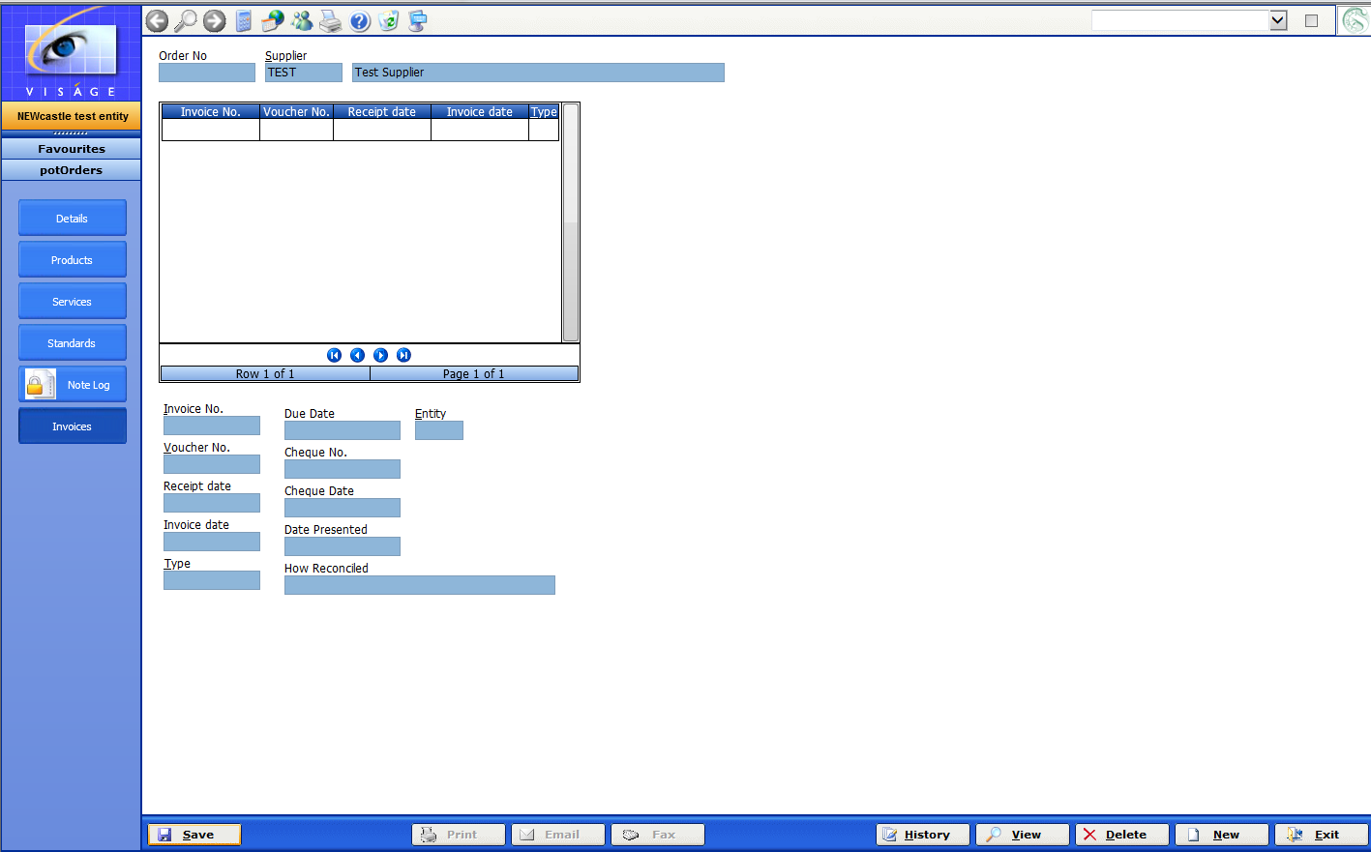 Orders - Invoices Screen
STANDARDS SCREEN

This screen will only appear, if you have the option: Using Standards in Purchase Order Parameters set to Yes. If you do not wish to use Standards, you can leave this field blank or turn the option off.

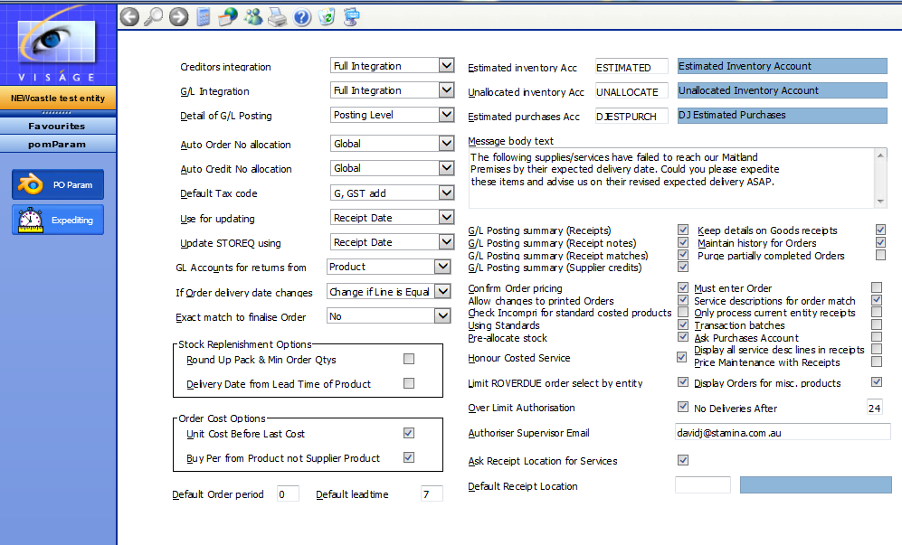

These are the standards that are to be specified as relating to the goods associated with this order.

Typically, standards are pre-defined rules or conditions that goods or services must conform to.

- Select Standard – Select the appropriate standard relating to the goods on this order from the available list, or alternatively enter as free form text, describing the standards to be applied to this order.

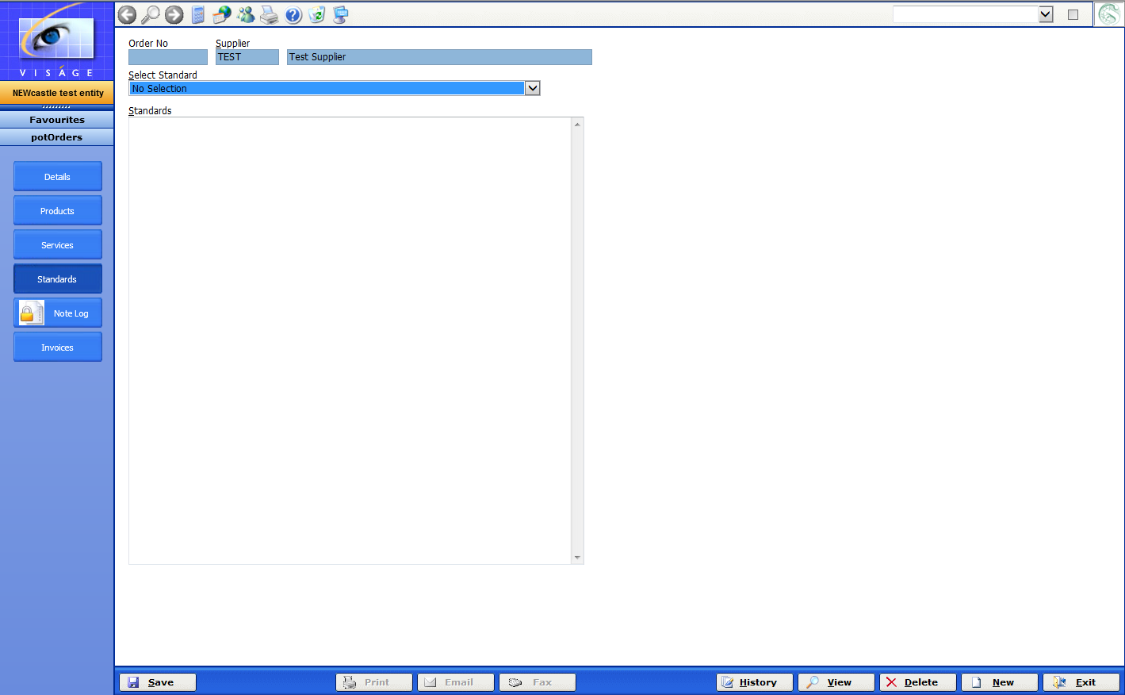
Orders – Standards

Click on Save button. Click on Print or Email or Fax Button to submit this Order to your Supplier.

NOTE LOG

A Purchase Order must be saved you can enter a note log entry.

If you attempt to open the Note Log screen prior to the Purchase Order being saved, you will receive the following error.

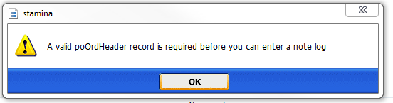
Note Log error

Note Log can be used throughout the system to record additional information, that you may find is not being stored elsewhere in the system.

The use of this screen is entirely optional. If you feel you do not need to record additional information you can leave this screen blank.

You may have the need to store external files eg. Quotes that have been raised in the system together with a Purchase Order that is being raised to Purchase the goods that have been included in the Quote, or anything else that you may find useful.

If you supply a Quote to your customer, and the customer accepts the Quote, you would then place an order for the goods. By storing a copy of the Quote with the Purchase Order, the person responsible for Authorising the Purchase Order is able to see the goods being quoted on and the goods being ordered. This is only a small example of what you could store in the Note Log process.

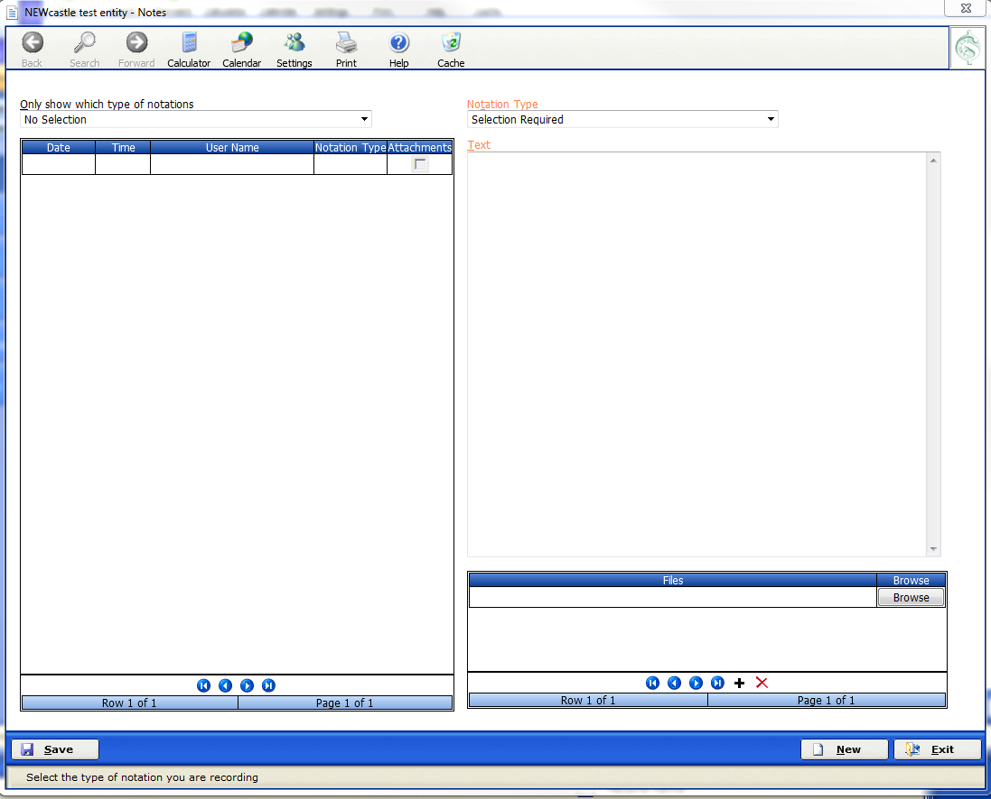Note Log Screen

- Notation Type – Select the notation type from the list of options that would best suit the information being recorded here. If there is no suitable option available, you can create a new type by locating the Notation Types process in the System Administration Menu.

- Text - Enter as free form text the notation details you wish to record here.

- Files – If you have the need to store external files relating to the Purchase Order in this case, you can select the file/s here. If you do not have the need to store external files, you can simply enter and save Notes.

What you store here, is entirely up to you.

  - Click the Browse button. Locate the external file you want to store here.
  - Click Open
  - Click Save

The external file is then stored in the Note Log process.

Click Exit to return to the Orders process or Click New to add another Note Log entry.

VIEW EXISTING ENTRIES IN NOTE LOG

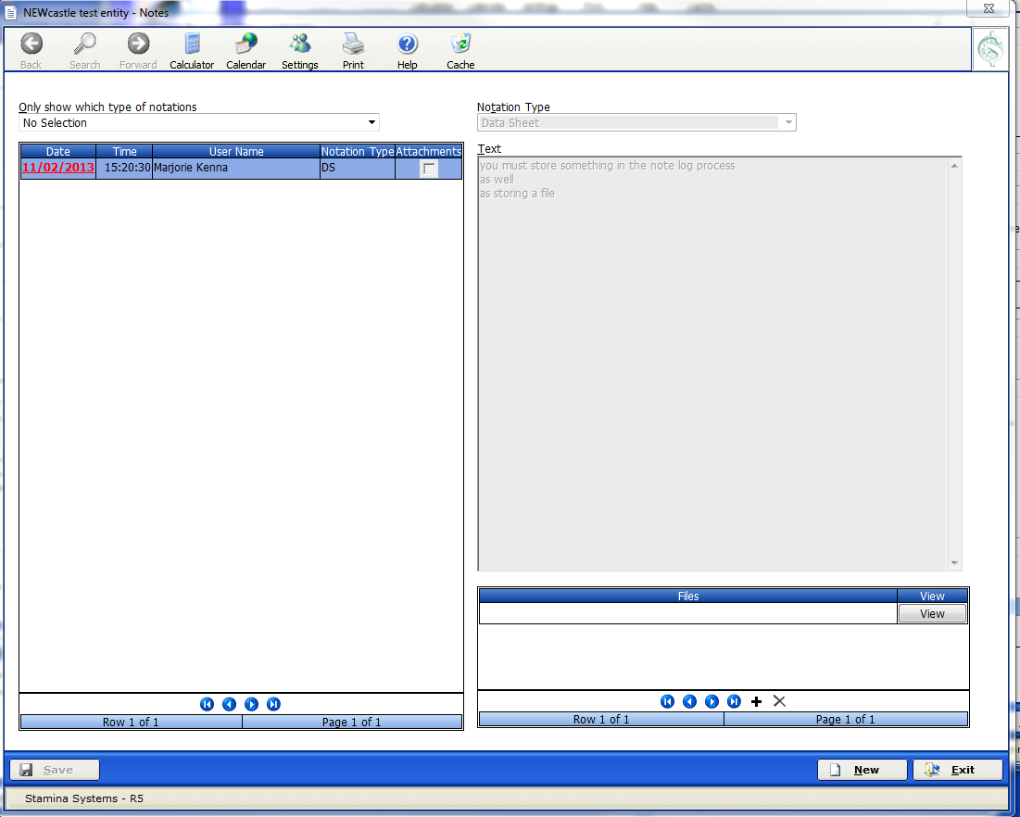
Note Log entry screen with saved notes

To view existing entries in Note Log:-

- Locate the Order process in the Purchase Order Transaction, Orders Menu.

- Enter the Purchase Order Number. Use the Search options if you are not sure of the number here.

- Select the Note Log button. The Note Log screen will then display with any existing entries.

- To view one of those entries –

  - Move Mouse over Date column and make your selection by clicking with the Mouse.
OR
  - Make your selection from the list of options in the ‘Only show which type of notations’ selection. The information that has been stored under the selected option will only display.

  - Date – This is the date the existing Note Log entry was saved.
  - Time – This is the actual time that the Note Log entry was saved.
  - User Name – This is the name of the user that saved this entry.
  - Notation Type – This is the Selection that was made in the Notation Type field when this entry was saved.
  - Attachments – This indicates whether any files were saved with this Note Log entry.

The Text area changes to be a display area. You cannot amend or delete an existing entry in Note Log.

You must Exit from the Note Log process before you can return to the original Purchase Order.

Even though the types of Notations are the same throughout the system, you cannot view a note log entry for the same Notation type from a different process than when it was originally saved.

For Example: If you have a Notation Type of Data Sheet. Under Purchase Orders you have entered a number of Note Logs for different Purchase Orders with a Notation Type of Data Sheet. Also under Suppliers, you have entered a number of Note Log entries for with a Notation Type of Data Sheet. You cannot view the Purchase Order Note Log entries under Suppliers, nor can you view the Note Log entries for Suppliers under Purchase Orders.

Each note log entry is specific to the process where it was originally created and saved.

