ORDER ENTRY - CREDITS

CREDIT ENTRY

This process is used to record Credits for the Order Entry System. Credits can only be raised against a Posted Invoice in the Order Entry Menu.

A Credit can be raised to Credit an entire Invoice, Credit one line of the invoice, credit a number of lines from an invoice or Credit one line from more than one invoice or credit a number of lines from more than one invoice. The Invoices and Special Charges button will only appear once a valid entry has been made in either Invoice No, or Customer Code fields.

Fields indicated as mandatory (Red Label) require data input where the other fields indicated with a Black Label do not necessarily require input, but any default entries in any of these field can be changed if necessary.
To access Help for all fields – position cursor in the field and press F1 or click on Help button.

To access Search for fields that have Search available – position cursor in the field, Click on Search Button, or right click and select Search option.

CREDIT ENTRY

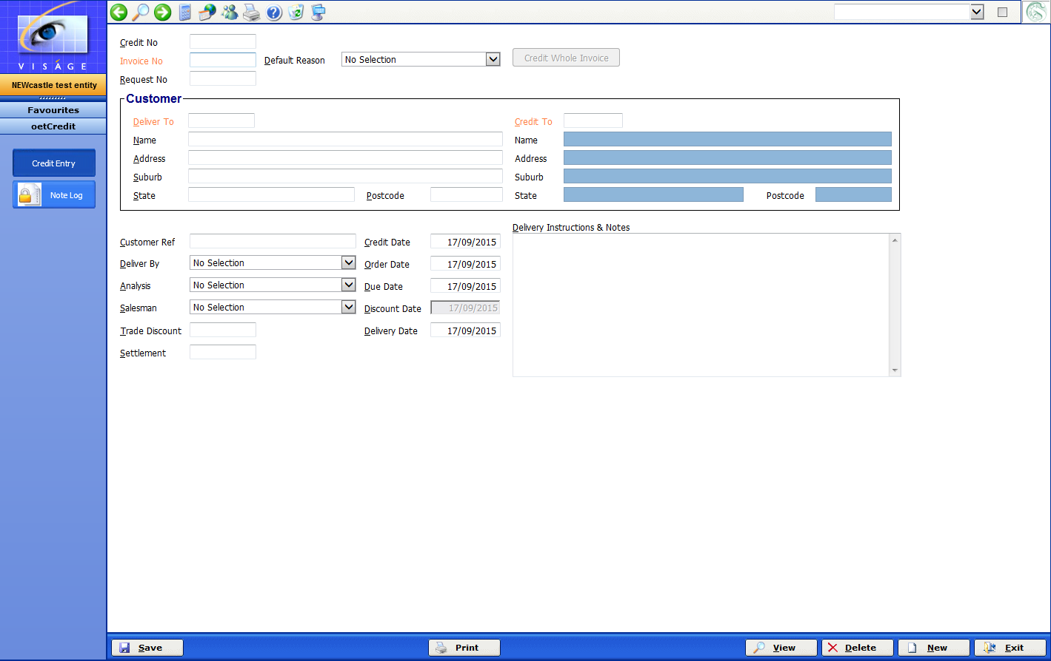
- Credit No – This is created automatically after the information has been entered in this process and the Save button has been clicked.

- Invoice No – Only use this option if you are crediting the entire Invoice.
Enter the Invoice Number in this field. Use Search features to locate the Invoice number if necessary.

- Default Reason – Make your selection from the available options here. If there is no suitable option available, navigate to the oemCreditReasons – Credit Reasons process and create another reason entry for use here.

If you have entered an Invoice No in the previous field and you are going to credit the entire invoice – select a reason in this field. The Credit Whole Invoice button will then be available to select.

- Credit Whole Invoice – This button will only be available to select if you have entered a reason in the previous field or you have entered a valid Invoice Number in the Invoice No field.

If you are crediting the entire invoice, you should click this button. The system will then locate the lines from the Invoice and will populate the Invoices screen and/or the Special Charges screen with those details. This saves you from having to know each line from the Invoice and having to manually key in each line to be credited.

If you are not crediting the entire Invoice, you should leave the Invoice No field blank on this Credit Entry screen, and you should not click the Credit Whole Invoice button. To credit single or multiple lines from an Invoice/Invoices see the Invoices Screen where you would enter each Invoice Number to be credited.

- Request No – This is an optional field that can be left blank if necessary. This field could be used to match up a Request No from your Customer with an actual credit raised by you.

- CUSTOMER –
Deliver to – This is the Customer Code that the Credit Note is delivered to.

If you entered an Invoice No in this screen and have selected to Credit Whole Invoice, the details displayed in the Customer fields will default from the Invoice to be credited.

If there has not been an Invoice number entered, you should enter the Customer code that this Credit will be raised against here. The Name, Address, Credit to, Name and Address will default with details that have been set in Customer File Maintenance process – armCustomers

Credit To – This is the Code for the Customer that will be credited with the value of the Credit Note.

The Deliver to and Credit to will in most situations, be the same but they can be different. There might be a case where goods were delivered to a Branch but the credit goes to the Head Office.

You can change any details in this area that are not display fields if required.

- Customer Ref – This is an optional field and might be used to record the Customer Order Number if one was supplied.
- Credit Date – This is the actual date the credit note is raised.
- Deliver By – Make your selection from the options available. These options are maintained by the ssmDelivCodes process. This is used to identify the delivery method of the goods.
- Analysis – Optional field that can be left blank if not required. Can be used for Analysis purposes.
- Salesman – This is the Salesman who raised the credit or the Salesman responsible for this Customer’s account. These options are maintained by the armSalesman process.
- Trade Discount – This is the Trade Discount % that is normally given to this customer. Leave blank in this is not applicable.
- Settlement – This is the Discount % that would normally apply to this customer if payment is received before the due date indicated.
- Order Date – This is the date on which the customer placed the original order.
- Due Date – This is the due date for this credit.
- Discount Date – Is a display field only. Information defaults from armCustomers – Customer File Maintenance.
- Delivery Date – This is the actual date that the goods were delivered.
- Delivery Instructions and Note – Free form text area that can be used for delivery instructions or any other notes relevant to this Credit / Customer.

In the below example, the entire Invoice 9874 will be credited.

- Enter 9874 in the Invoice No field and press <enter>

The details from Invoice 9874 are retrieved by the system and Customer / Deliver to and Credit To details, as well as Dates and any Delivery Instructions and Notes from Invoice 9874, are displayed on this screen.

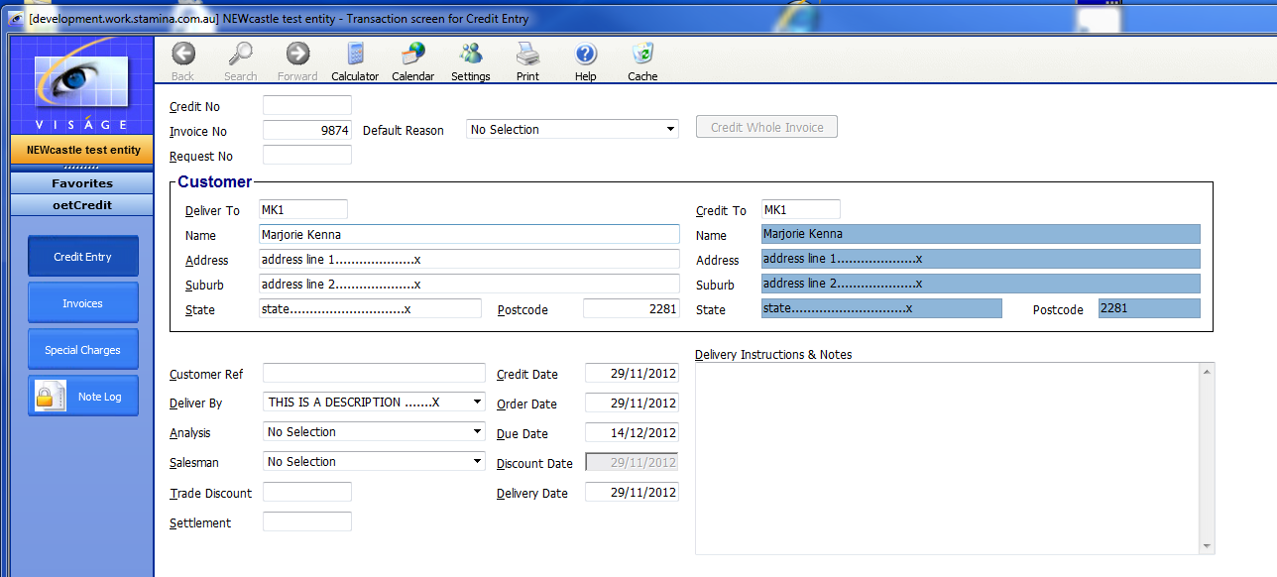

- Select a Default reason – why this credit is being raised.

- Click Credit Whole Invoice button. The system will look up the details from the invoice and display the lines of the invoice on the Invoices and Special Charges screen of this process. A Credit No will be created and the Customer details fields will change to be display fields only. – see below figure.

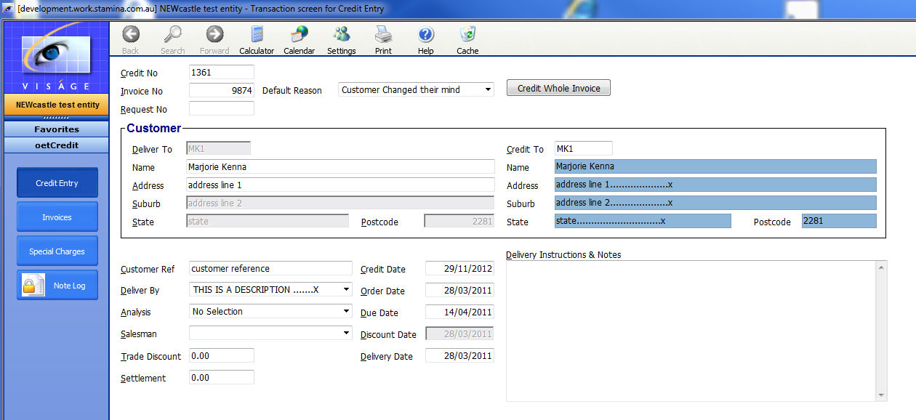
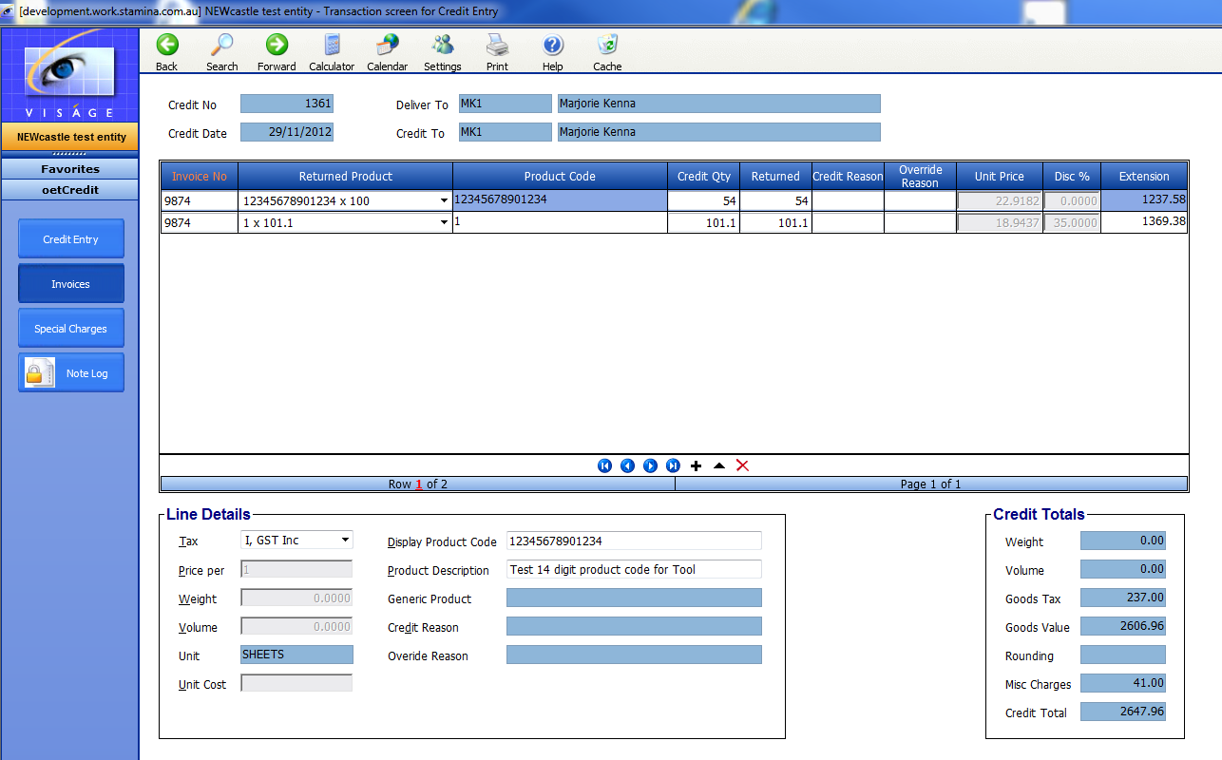

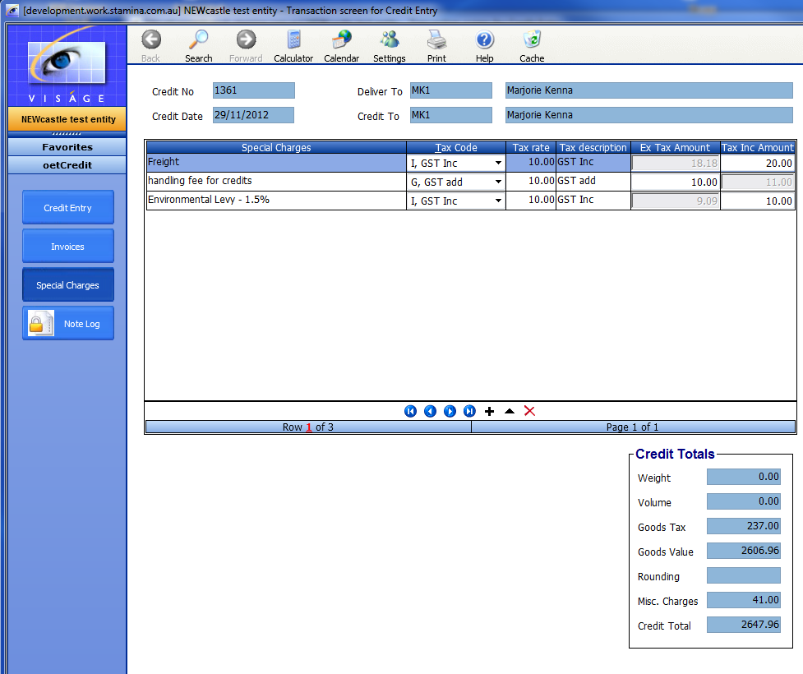
INVOICES SCREEN

If you have selected to Credit a whole Invoice from the Credit Entry Screen – the table on this screen will be populated with the lines from the Invoice.

If you did not select to Credit a whole Invoice, you must enter an Invoice number as the first field on this screen. You cannot enter a returned product without first entering an Invoice Number.

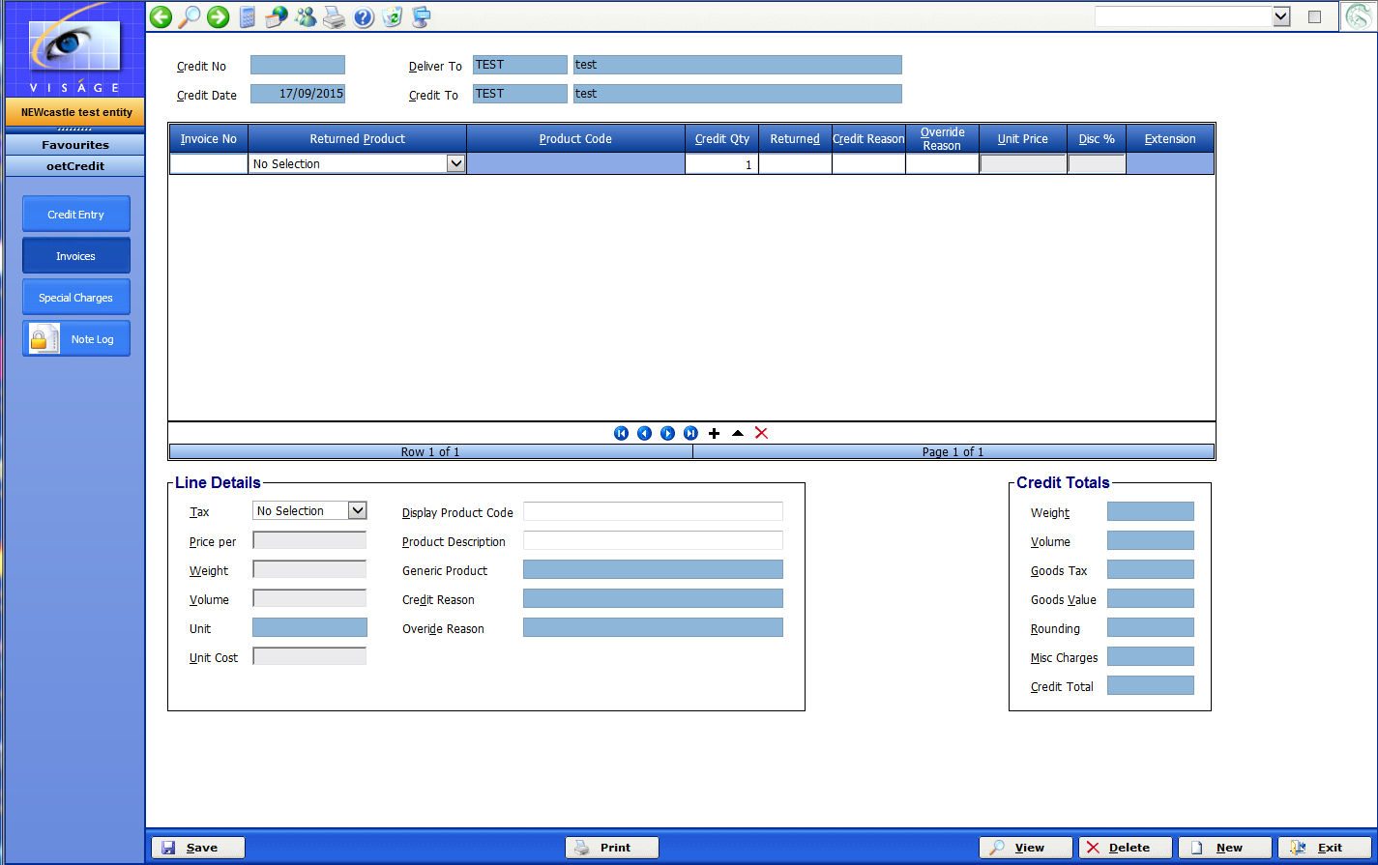

- Invoice No – This is the Invoice number that you want to credit. You can use the Search function to locate an Invoice at this point if necessary. You can only enter an Invoice number for the nominated Credited customer. If you try to enter an invoice number for another customer you will receive the following error message.

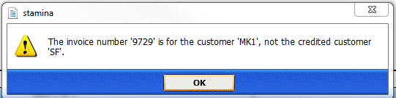

- Returned Product – This will default with lines of products from the Invoice number entered in the previous field. Make your selection from the list of the products being returned. Format will be – Product Code x Qty.

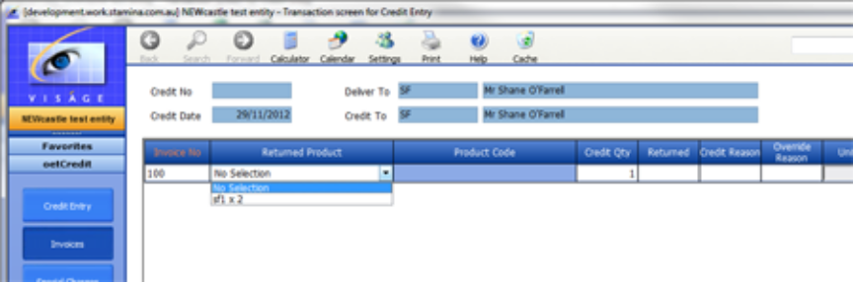

- Credit Qty – This is the quantity of the product that you wish to credit. The Qty from the original Invoice will default here. This can be changed if necessary.

- Returned – This is the actual quantity of this selected product that is being returned. The Qty from the original invoice will default here. This can be changed if necessary.

The Credit Qty and Returned Qty might be different where, a credit is being raised for a qty of 5 but only 2 have been returned because the remaining 3 have been broken and have been disposed of. Eg. Originally 5 light globes were sold on invoice 123. The globes supplied were the incorrect type but in transit, 3 of the globes have been broken. In this situation we are raising a Credit for the 5 but only 2 have actually been returned.

- Credit Reason – Use Search to locate a valid Credit Reason. Credit Reasons are maintained by the oemCreditReasons process.

- Override Reason – If you wish to over ride the unit price of the item being credited, enter a valid reason here. Use Search to locate a valid Override Reason. Override Reasons are maintained by the oemOverideReas process. If you do not wish to over ride the price for this item, leave this field blank.

- Unit Price – This is the unit price that was charged when the original invoice was raised. This is a display field and can only be changed if a valid Override Reason is entered in the previous field.

- Disc % - This is a display field and can only be changed if a valid Override Reason is entered in the previous field.

- Extension – This is a display field only and is the price extension for the row of this table, taking into account the Credit Qty, Unit Price and Discount.

Click on the + Add a row option in the Table if you wish to Credit additional items.

If you have to credit more items from this Invoice or another Invoice for this same customer, you can add another row in this table, enter the Invoice No and select the lines from this Invoice that are to be credited.

SPECIAL CHARGES

If you have any special charges that have been created on your system, and a credit is to be raised against any of these changes, enter the details here.

Special Charges are maintained in the oemParam – Order Entry Parameters process- OE Param B screen.

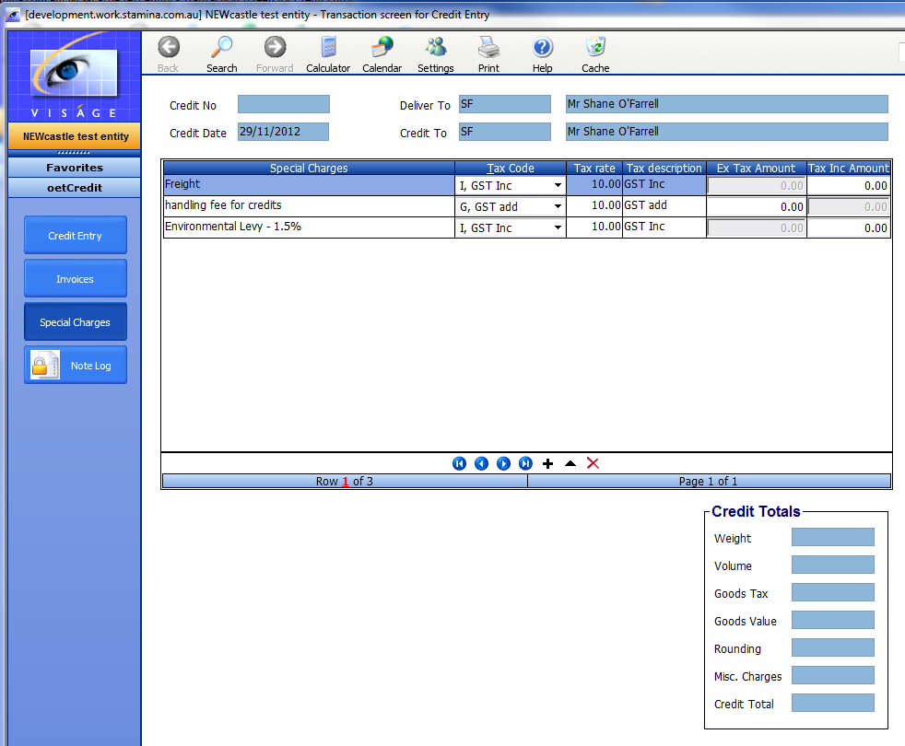

Click Save button to save the Credit Entry details.

NOTE LOG SCREEN

After you have saved the Credit Entry (a Credit No will be created) you can select the Note Log option to record any information that you may find useful for future reference.

If you select the Note Log button before a credit note number has been created, you will receive an error advising you that ‘credNo required before you can make an entry to the note log’.

- Notation Type – Select option from available list. Notation types are maintained by the ssmNotetype process.
- Text – Enter the free form text that you wish to record here.
- Files – If you have any files that you would like to store in this Note Log, click on the Browse button and locate the files.

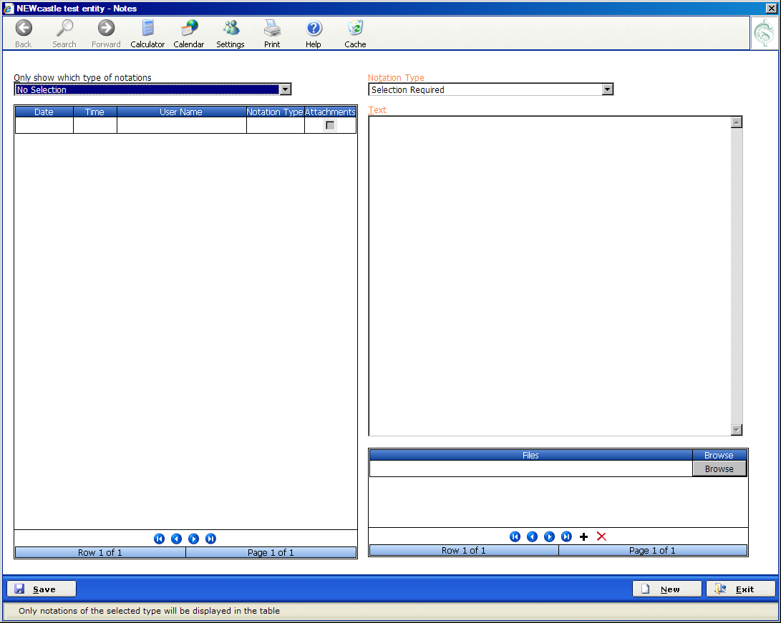

Click Save button to save any details entered.

When you have saved a Note Log, the details will then appear in the table on the left of screen.

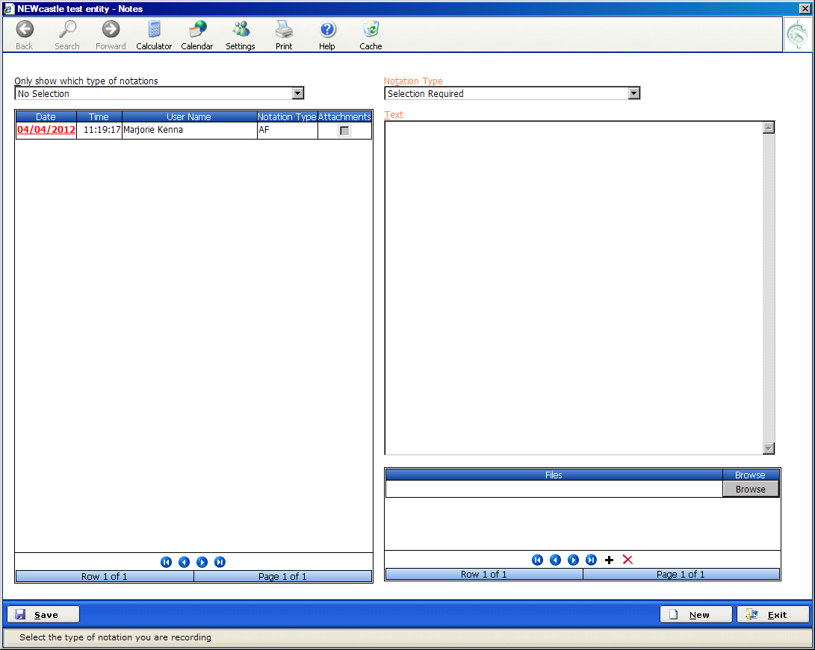

If you wish to view existing entries in Note Log – select the date you wish to view, click on the date, and the details of that note will appear in the table right of screen. These notes can only be reviewed. You cannot make any changes to an existing Note Log entry.

Click Exit button to return to Credit Entry process.

When you have completed the entry of all details for this credit Note, select the Print button to produce a hard copy of the Credit Note.

Click Save to save any information.

Click Exit to return to the Menu.

PRINT CREDIT NOTES

To print a single Credit note, click on the Print button from within the oetCredit process.

To print a run of Credit Notes, you can use the oerPrintCrn process.

REPRINT CREDIT NOTES
To reprint a run of Credit Notes, you can use the oetRePrtCrn process.

A Credit Note must have been printed previously before you can reprint it.

UNPRINT CREDIT NOTES
To unprint a credit note that has not yet been posted, use the oetUnPrtCrn process.

A Credit Note must have been printed previously before you can unprint it.

CREDIT NOTE EDIT LIST
Review the Supplier Credit Notes/Adjustment list to make sure your entries are correct prior to running the Supplier Credits post process.

SUPPLIER CREDITS POST
Run this process when you are satisfied the entries are correct. This process will update the related systems. Credit Notes must be printed before they can be posted.

