SUPERANNUATION

The Superannuation End of Period Menu – found in the Payroll, Other Functions, End of Period Processing Menu contains the necessary functions to complete the calculations for Superannuation Guarantee Contributions (SGC) for the pay period.

After the last pay has been run for the month, you must complete the Calculate Super (SGC) function. This calculates SGC for the period according to the different percentages and Superannuation Suppliers as set up in your Employee Maintenance files, which is found in the Payroll Maintenance, Employee Details process. (See Data Entry of Employee Details.doc template for these details.)

A number of processes throughout the system must be set up in order for the Superannuation Calculation to be correct. Eg. Payroll Parameters, Accounts Payable, Maintenance – Suppliers, Payroll Maintenance – Employees, Payroll Maintenance – Additions and Deductions and Factors

Fields indicated as mandatory (Red Label, eg. From Customer, Receipt type etc.) Require data input, where other fields (Black label eg. Deposit Number etc.) do not necessarily require data input, but any default entries in any of these fields can be changed if necessary.

To access Help for all fields – position cursor in the field and press F1 or click on Help button.

To access Search for fields that have Search available – position cursor in the field, Click on Search Button, or right click and select Search option.

PAYROLL PARAMETERS – SUPERANNUATION

- Min Monthly Earnings for SGC – This is the minimum monthly earnings that an employee must have in order to be eligible for Superannuation Guarantee Charge (SGC) payments, and is currently set at $450 by the ATO, but may be lowered if you wish to be more "generous"

- Max Monthly Earnings for SGC – The ATO has sets a maximum superannuation contribution base each year, If you wish to apply this maximum limit/cap, then you should enter the amount here. Check with the ATO as the current Maximum level.

If you don't want to apply these limits, then enter 999999 into this field

- SGC Expense Account – This is the account to which the Superannuation Guarantee Contribution (SGC) should be applied. Typically, it will be an expense item in the Profit and Loss account.

- SGC Tax Code – This is the GST code relevant to the SGC expense. Superannuation does not have any GST applicability, therefore, the tax code here should be free of any GST. ie, the code you already have set up for no GST.

- Minimum SGC Percentage – This is the percentage rate that the SGC will be calculated at. Check with the ATO as to the current Minimum SGC Percentage.

- Last SGC Posting Date - This is the last date that the SGC calculation was posted. It will be automatically updated after each posting of the super calculations each month.

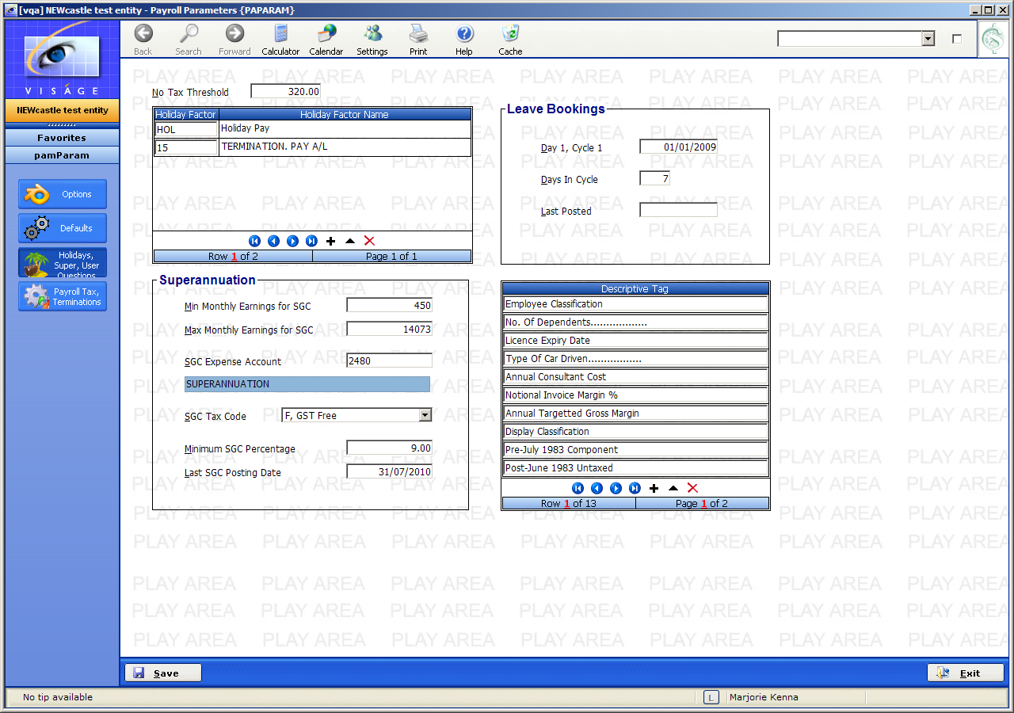
Figure 1: Payroll Parameters - Superannuation

ACCOUNTS PAYABLE

You have to set up each of the Superannuation providers to whom you will be making payments as a Supplier under the Accounts Payable, Maintenance Menu – Suppliers process.

See the Create Suppliers Manual Template for directions on setting up/creating Supplier entries.
PAYROLL MAINTENANCE – EMPLOYEE DETAILS

Once each Super provider has been created as a Supplier, you must assign each Employee to their nominated Super Supplier code.

- Navigate to the Payroll Maintenance Menu and locate Employee Details.

- Click on Employee Details. Enter the Employee Code. Click on the Tax & Super button

- Exclude from Super: If you do not wish this Employee to be included in the Super Calculations when you run Calculate Super – select No, do not exclude. When you run the Calculate Super process, this employee will be included in any calculations. If you selected Yes, Exclude from calculation, when you run the Calculate Super process, this employee will not be included in any calculations.

- SGC Expense Account: This field allows you to override the default Expense Account set in Payroll Parameters. The system records the Expense Account on the Employee at the time of posting the Pay. When you run the Post Super process, the system will use this Expense Account for Super Calculations on that pay. Any extra employer amounts will use the Expense account associated with the last pay in that period.

The idea is that you may want to change the Expense Account based on a number of factors – Pay Departments for instance. The Employee may change departments during the month, so we always use the Expense Account at the time of posting the payroll.

If you leave the SGC Expense Account here blank, the account from Payroll Parameters will be used.

- Super Fund – Enter the Super Supplier code.

- Membership No – Enter the Employees Super fund Membership No.

- Membership Name – This can be left blank and the name from the Employee entry will be used. If the payment is being paid into another persons name, that name can be entered here.

- Min Amount / Per – The selection made in these fields determines how the Minimum amount of super is calculated. An amount is entered in the Min Amount column. You are then required to make a selection in the ‘Per’ column. Valid selections are Period or Week. Select Period if you wish the minimum super amount to be calculated per SGC period. That is, if the calculated super amount for the whole period is less than the minimum amount, then the minimum amount will be used as the super for the whole period.

If Week is selected, than the minimum amount will be treated as the minimum amount of super per week.

If an employee is paid weekly and the total for all pay packets on a given posting results in a super amount less that the minimum amount then the minimum amount is used for that week.

If the employee is paid fortnightly, the calculated super amount is compared to twice the minimum amount. Treating the fortnightly, calculated super amount is compared to twice the minimum amount. Treating the minimum as weekly rather than per pay allows the system to automatically adjust if, for instance a weekly employee is paid two weeks holiday pay in one pay.

- Extra Amt – This is the extra amount the Employer will contribute to this fund for each super period. Leave this field blank if there is no extra amount applicable here.

- SGC Percentage – This is the SGC percentage that the Employer will contribute to this fund for each super period. Enter at least 9% here.

- Save any changes.

IT IS YOUR RESPONSIBILITY TO HAVE EMPLOYEES SET UP CORRECTLY.

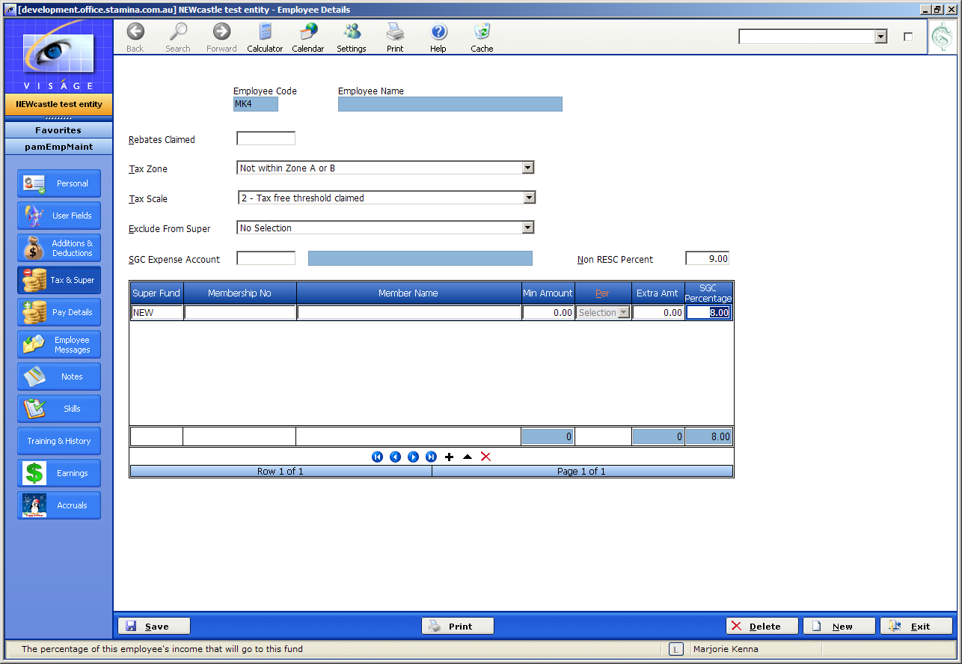
Figure 2: Employee Maintenance
PAYROLL ADDITIONS

Navigate to the Payroll Additions process in the Payroll Maintenance Menu.

Each Pay Addition must be investigated to ensure that depending on the type of Addition it is ticked or left blank.

- Increase SGC Earnings - Tick this field for Yes - then the addition code will be used in the calculation of Gross Income for the Superannuation Guarantee Calculations.

If you do not tick this field - for No then the addition code will NOT be used in the calculation of Gross Income for the Superannuation Guarantee Calculation.

- Save any changes.

IT IS YOUR RESPONSIBILITY TO HAVE THE PAY ADDITIONS SET UP CORRECTLY.

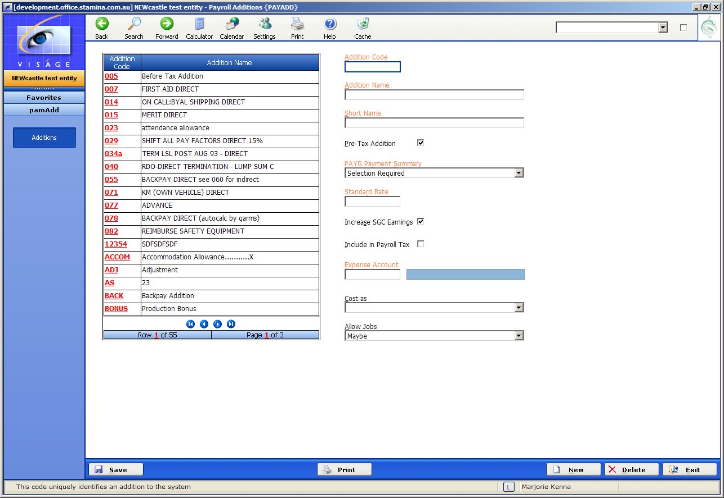
Figure 3: Payroll Additions
PAYROLL DEDUCTIONS

Navigate to the Payroll Deductions process in the Payroll Maintenance Menu.

Each Pay Deduction must be investigated to ensure that depending on the type of Deduction it is ticked or left blank.

- After Tax – leave un-checked if the deduction is before tax i.e. Salary Sacrifice

- Decrease SGC Earnings - Tick this field for Yes - then the deduction code will be used in the calculation of Gross Income for the Superannuation Guarantee Calculations.

If you do not tick this field - for No then the deduction code will NOT be used in the calculation of Gross Income for the Superannuation Guarantee Calculation.

- Employee Influenced – Tick this field if the employee has been able to influence the decision for this deduction (refer to Reportable Employer Superannuation Contributions information from Tax Office).

- Super Salary Sacrifice – check the field if the deduction is a Salary Sacrifice

- Superannuation Fund – select the Fund from the drop down box to the right side of the field (this will have been entered already for Accounts Payable)

- Deduction Priority – the entry here (1 – 99) decides the prioiry of this deduction over others i.e. 1 is highest.

- Standard Rate – if there is to be a standard rate for this type of deduction, it can be entered here. However, it can be overwritten in the Employee Maintenance file or when actually entering in payroll details on pay day.

- G/L account – is the General Ledger account to which this deduction applies.

- Partial deduction OK – check the box if you allow for a part of the deduction to be made rather than only the complete amount.

- Workplace Giving – if the deduction is one that will be identified on the Payment Summary, then check the Workplace Giving field or if for Union or Professional fees, check the relevant field or the neither field if it is a private employee deduction form wages.

- Save your work

IT IS YOUR RESPONSIBILITY TO HAVE THE PAY DEDUCTIONS SET UP CORRECTLY.

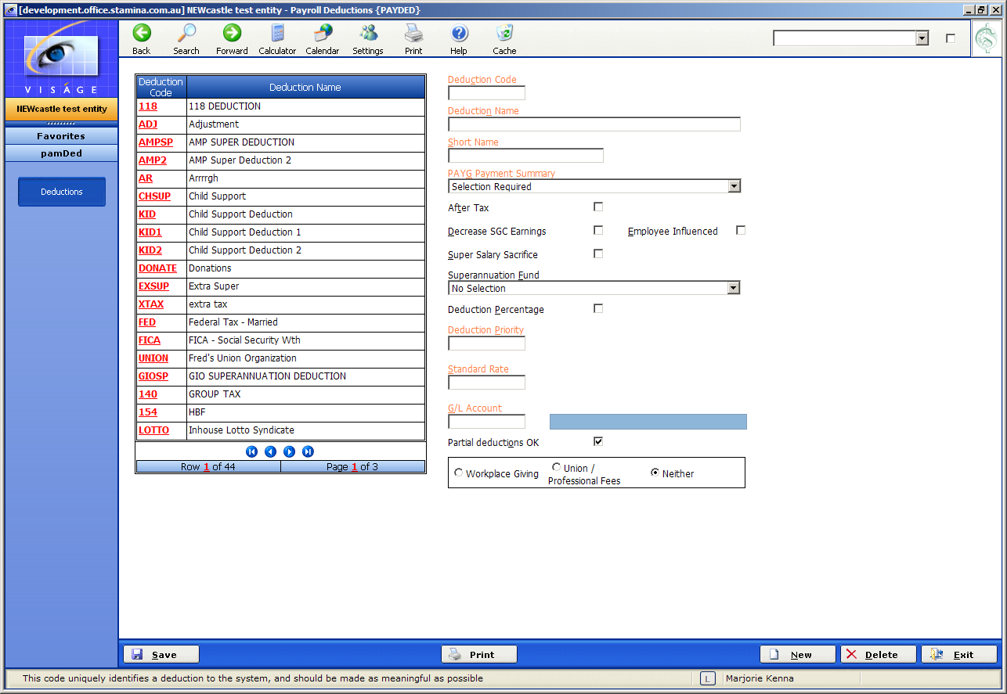
Figure 4: Payroll Deductions

PAY FACTORS

Navigate to the Payroll Factors process in the Payroll Maintenance Menu.

Each Pay Factor must be investigated to ensure the correct SGC Factor has been set up according to the type of Pay Factor being used.

For Example, Normal Time should show a Pay Factor of 1.00 and should have a SGC Factor of 1.00 as well. However, an Overtime Factor which under normal circumstances, is not subject to SGC, should have a SGC Factor of 0.00.

IT IS YOUR RESPONSIBILITY TO HAVE THE PAY FACTORS SET UP CORRECTLY.

If you need to confirm which pay factors or additions are affected by the SGC, you can go to the ATO Web site and follow through to the Superannuation section looking for, amongst other things, ordinary time earnings.

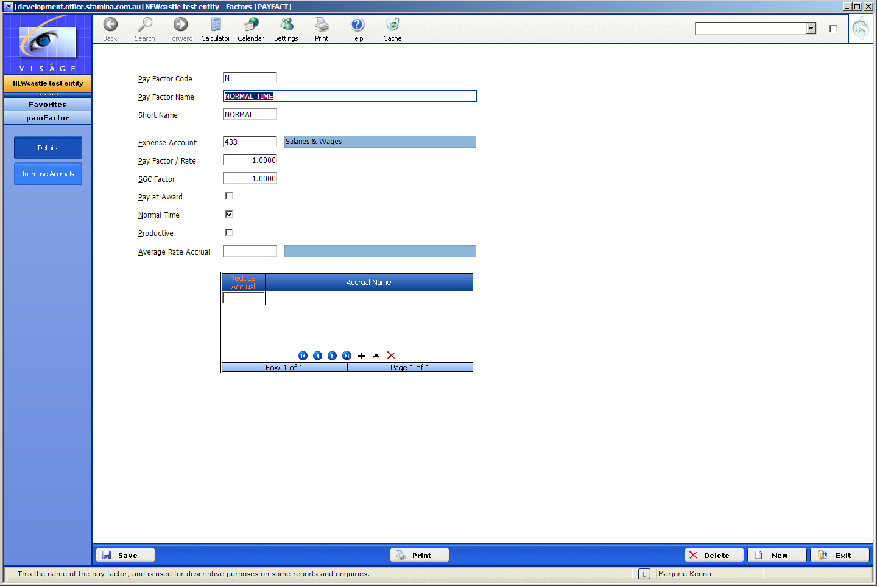
Figure 5: Pay Factors

In summary:

- Make certain all Pay Factors, Additions and Deductions are set up correctly. (Payroll Maintenance Menu – Pay Factors, Pay Additions and Pay Deductions process)

- Make certain all Superannuation details in Payroll Parameters have been set up correctly. (Payroll Maintenance Menu - Parameters process)

- Set up each Super provider as a Supplier. (Accounts Payable Maintenance Menu - Suppliers process)

- Add each Super Supplier code to each Employee Code in Employee Details process. (Payroll Maintenance Menu – Employees process)

- Make certain each Employee has been set up with at least 9% SGC in Employee Details process. (Payroll Maintenance Menu – Employees process)

- After the final pay has been run for the period, run Calculate Superannuation, Edit Superannuation and finally Post Super. (Payroll Other Functions Menu , End of Period Processing, Superannuation End of Period – Calculate Super, Super Edit List and Post Super process)

- Make the SGC Payments using the Manual Selection process in the Accounts Payable, Transactions – Payments Menu and pay the super funds. Print a report to accompany payment. (Payroll Reports Menu – Monthly Super Rpt)

- Issue each Employee with notification of the funds paid into their Super Fund. (Payroll Menu, Payroll Reports, Superannuation Reports Menu – Employee Super Report)

CALCULATE SUPERANNUATION FOR A PERIOD

Period Start – This is a display field and will default with the date from the previous time when this process was run and will be the date that the SGC has been paid up to previously.

Period End – This is the last date of the period for which you need to calculate the Superannuation contributions.

Click on the Calculate Button after you have entered a date in the Period End field.

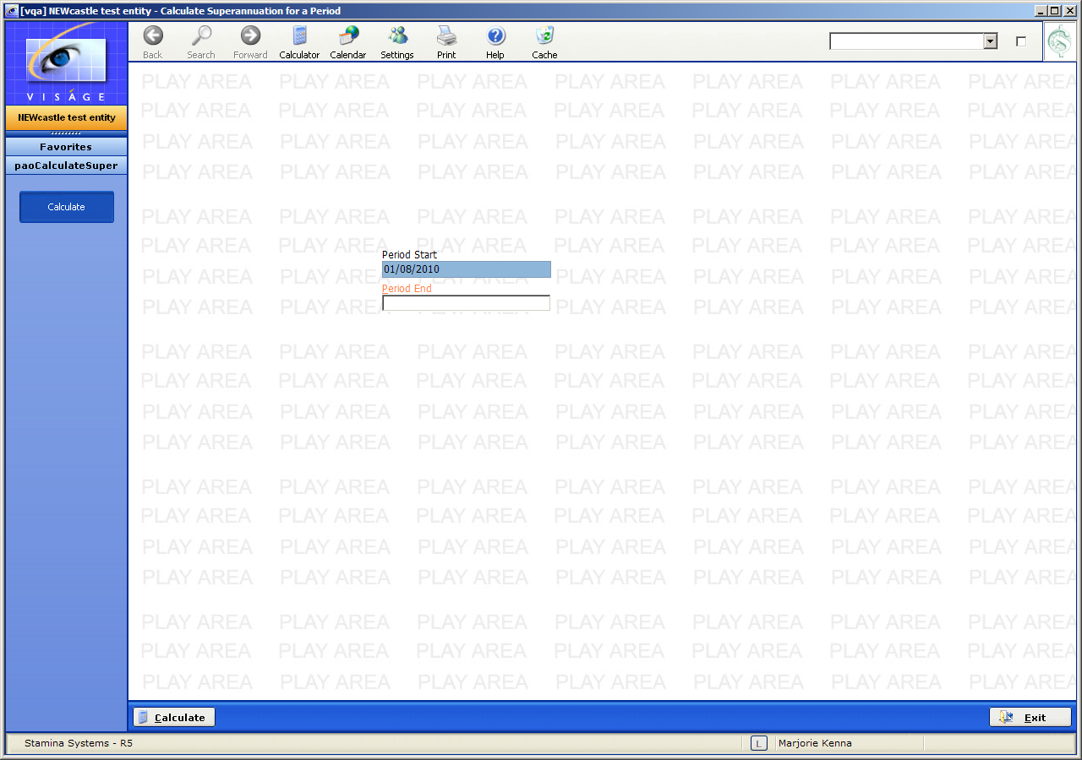
Figure 6: Calculate Superannuation for a Period Screen

This process produces a report that lists two types of errors – Fatal Error and Warning.

The Fatal Error can include:
- The Superannuation parameters not being set up.
- Outstanding pays or re-banks prior to the nominated period end date.
- No Supplier code against a super fund.
- The Employee’s total SGC Percentage being less than that set on Payroll Parameters, Holidays super and User Questions screen.
If any fatal errors are products, you will not be able to post the Super via the Post Super process. You will need to fix the errors and then re-run the Calculate Super process.

If you receive a Warning error regarding an Employee’s total SGC percentage is greater than that set on Payroll Parameters, Holidays, Super and User Questions page – Minimum SGC Percentage field, this will not prevent you posting unless there are also fatal errors present.

After Calculate Super has been run, you should print out the Super Edit List. This list will show all the calculations along side each Employee. You should check this report carefully to ensure that it is accurate.

If any errors relate to SGC (you may have a wrong percentage or an addition is not classified to increase SGC earnings etc.) are found, you can go back and change the item in question and then re-run Calculate Super. This can be done as often as needed.

You can run Super Edit List even if there are fatal errors in the Calculate Superannuation process.

The Calculation Percentage should have already been set up in Payroll Parameters, found in Payroll Maintenance Menu. This should be set to 9% currently.

You can use the Super Edit List and the Calculate Super process as your adjustment tools for SGC amounts. Once satisfied that the amounts are accurate, you should run Post Super.

The Post Super function posts all the amounts away to their relevant accounts etc and also creates and posts Vouchers for each of the Superannuation Companies. Remember, All SGC providers should have already been set up in Accounts Payable, Maintenance, Suppliers process. – see the Create Suppliers Manual Template for directions on setting up/creating Supplier entries.

RESET SUPER

If you discover that an Employee needs to be paid an additional amount or there has been an error in wages that necessitates another pay within the pay period that Is been used to calculate SGC, you will not be able to create the Payroll – via Payroll Transactions, Paymaster Functions, Generate a Pay with a Pay Journal Date that is prior to the Last SGC Posting Date, unless you run the Reset Super process.

Nor will you be able to create a pay with a Pay Journal Date prior to the Period End Date specified in the Calculate Super process if there are un-posted Superannuation details, unless you run the Reset Super process.

If you need to create a pay with a Pay Journal date before the Calculate Super Period End Date, you must run the Reset Super process. This is to prevent pays being missed by the Superannuation Calculation processes.

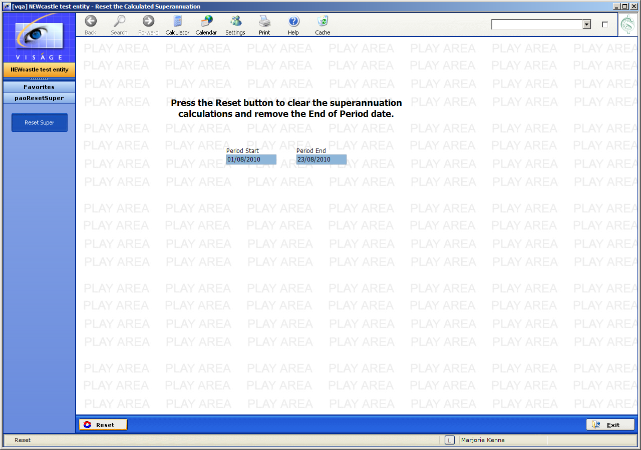
Figure 7: Reset Super

Proceed with the payment as you would if you were running your End of Month Accounts payable payment run.

The Superannuation Reports can be found in the Payroll, Payroll Reports - Superannuation Reports Menu.
EMPLOYEE SUPER REPORT

As part of Government Legislation a report must be generated for each employee AFTER you have completed the payment procedures and payment has been made to the SGC provider.

- Report Start Date - This is the first date of the period for which SGC amounts were paid.

Note that this refers to the Trx Date of the cheque voucher that paid the
Superannuation, not the payroll dates that generated the superannuation.

- Report End Date - This is the last date of the period for which SGC amounts were paid.

Note that this refers to the Trx Date of the cheque voucher that paid the Superannuation, not the payroll dates that generated the superannuation.

- Letter or Payslip Message – Select Letter if you wish to produce letters for your employees advising them of the super payments made on their behalf in the specified period.

Enter Payslip Message if you wish to advise your employees by way of messages on their next payslip.

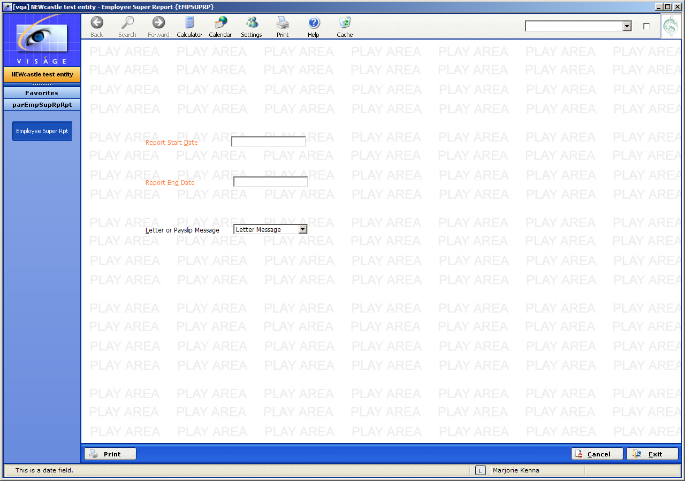
Figure 8: Employee Super Report

MONTHLY SUPER REPORT

This report details all the contributions paid on behalf of Employees to their respective SGC providers.

A new page will commence for each SGC provider so that the report can be used to send directly to the provider with the relevant SGC payment.

You will be able to generate the report based on SGC pay period end dates.

- Report for Month Ending – Enter the last date of the pay period for which Superannuation Guarantee Contributions (SGC) was calculated.

- Entity Group – Select the Entity for which superannuation entries were made. Only those Entities within this group will be included in this report.

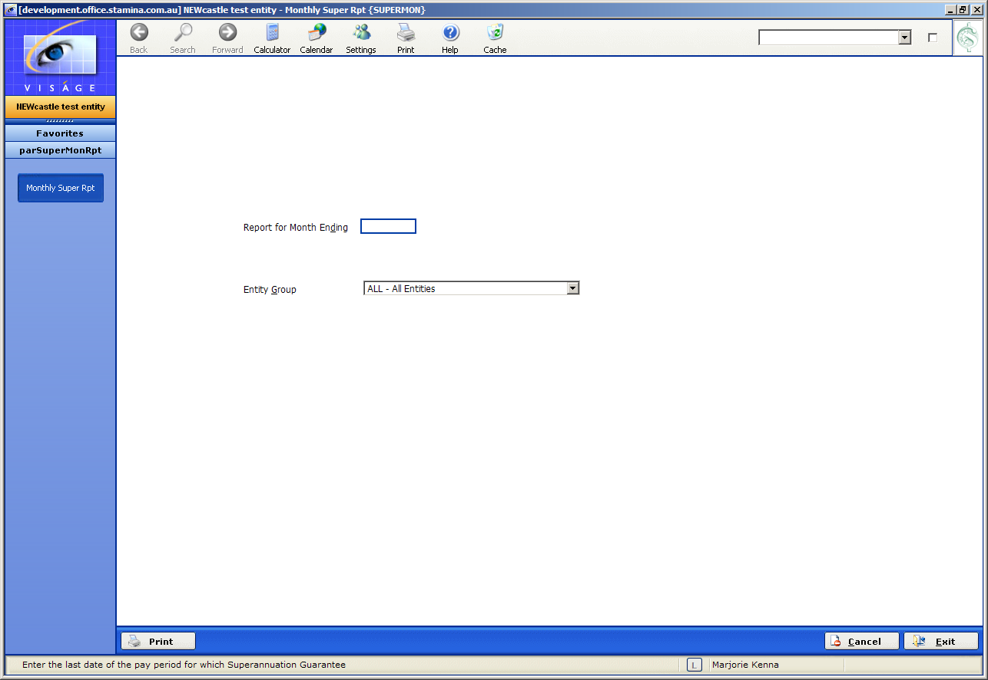
Figure 9: Monthly Superannuation Report for Entity

SUPERANNUATION REPORT FOR A DATE RANGE

This report produces a super report similar to the Monthly Super Report, but for a range of dates rather than a single month.

- Start Date – This is the starting date that you want to use for this process, and must be entered. Only transactions dated on or after this date will be considered by the process.

- End Date – This is the ending date that you want to use for this process, and must be entered. Only transactions dated on or before this date will be considered by the process

- Entity Group – Only Superannuation entries made from this Entity will be included for selection in this report.

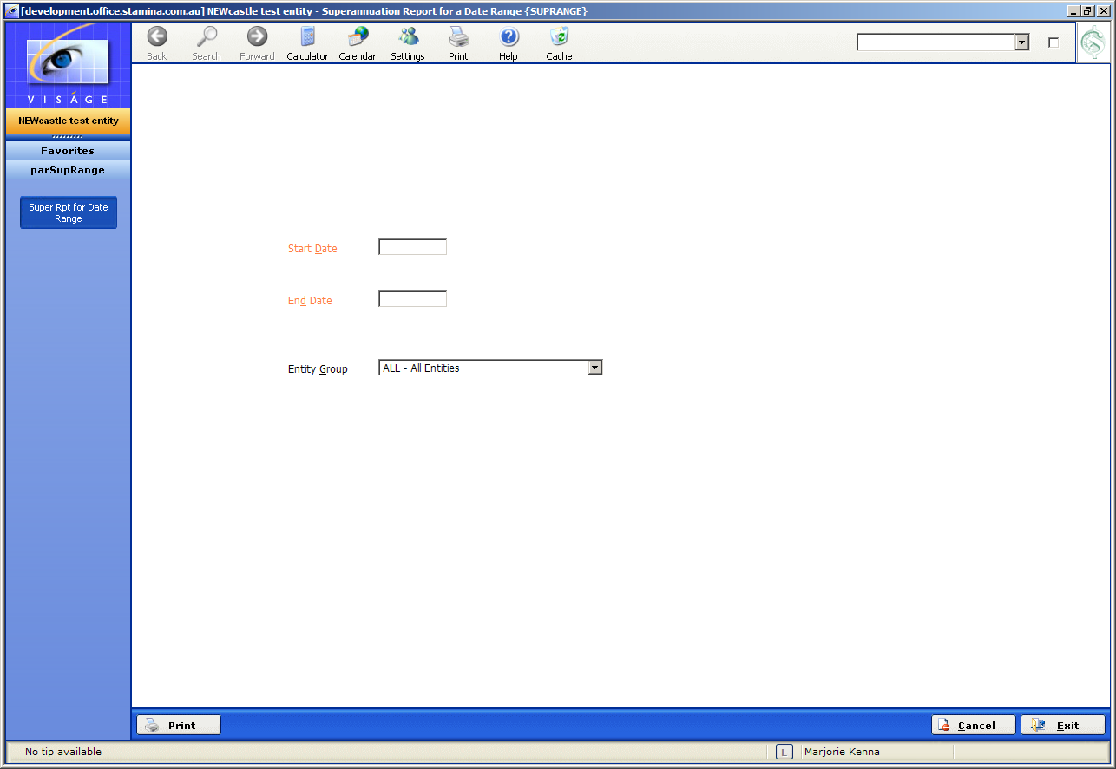
Figure 10: Superannuation Report for a Date Range

POST SUPER

The Post Super is the final stage of calculation and transferring the Superannuation data to appear under Creditors.

The payment procedure will be similar to your current procedures for payment of Creditors (see the Pay suppliers via Automatic Transfer document template).

- Voucher Trx Date – Will default to the date entered for the Super Calculations for the current period.

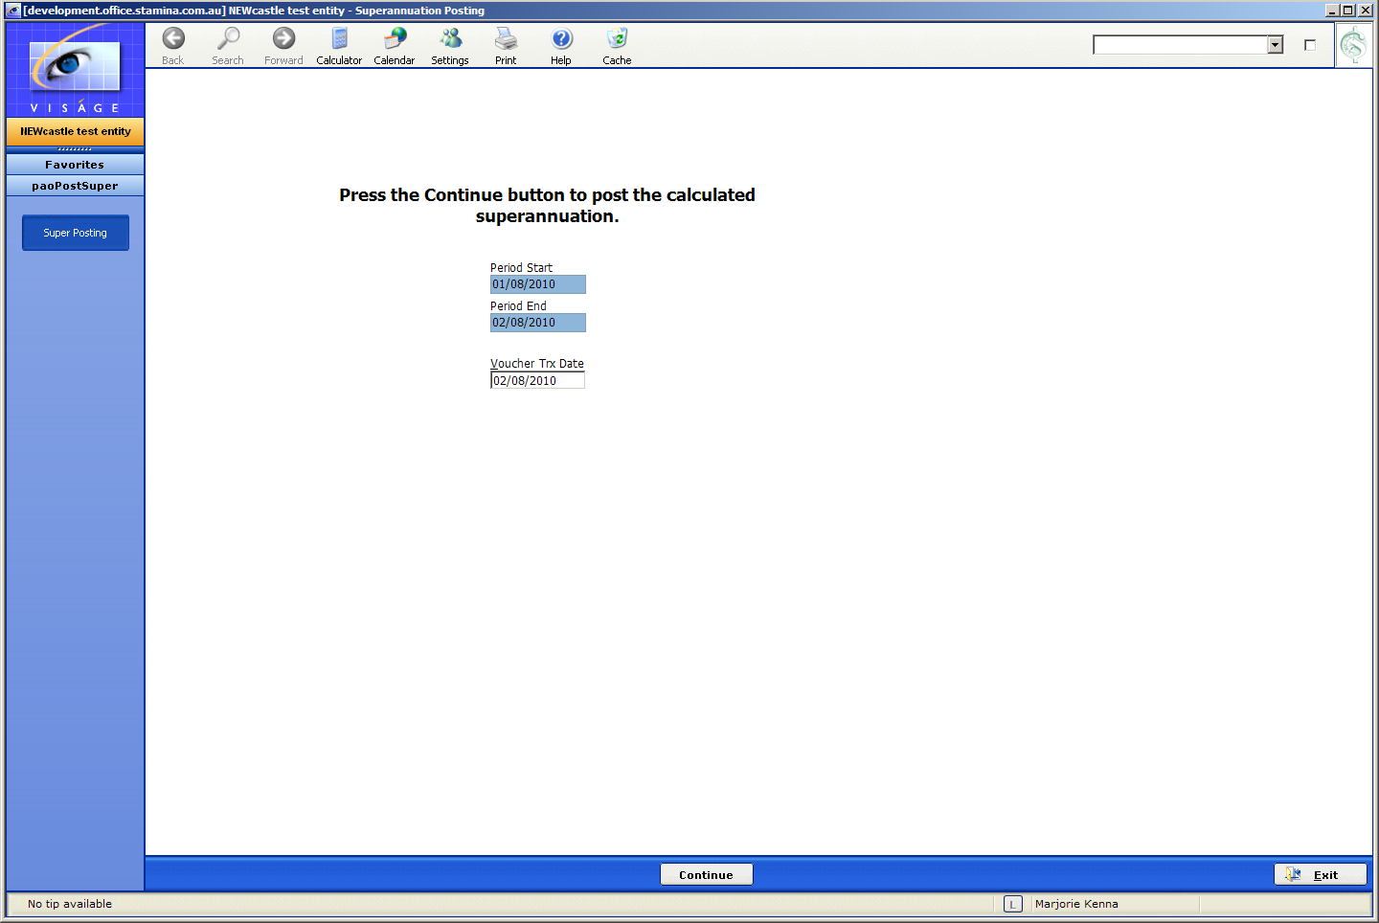
Figure 11: Superannuation Posting

NOTE!!!

You cannot part pay a Voucher generated from the Superannuation system.

If you are using the Manual Selection to select Super vouchers for payment, you will not be able to enter discount or dollar amounts for the voucher – the system will default to the full payment amount.

