SUPPLIER CREDITS
To create a Supplier Credit entry, navigate to the potsupCred – Supplier Credit process in the Purchase Order Transactions Menu.

This process is used to record an actual Supplier Credit.
Setting the option of Creditors Integration and G/L Integration to full in the Purchase Order Parameters process - will automatically update these systems at the time of posting a Supplier Credit, otherwise depending on the options chosen transactions are placed on system transaction files, and will have to be posted to the ledger by the operator where the Interface option is selected. If No integration is selected, no transactions of any kinds are generated for either Accounts Payable and/or General Ledger.

Fields indicated as mandatory (Red Label) require data input where the other fields indicated with a Black Label do not necessarily require input, but any default entries in any of these field can be changed if necessary.
To access Help for all fields – position cursor in the field and press F1 or click on 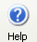Help button.

To access Search for fields that have Search available – position cursor in the field, Click on 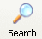Search Button, or right click and select Search option.

SUPPLIER CREDIT SCREEN

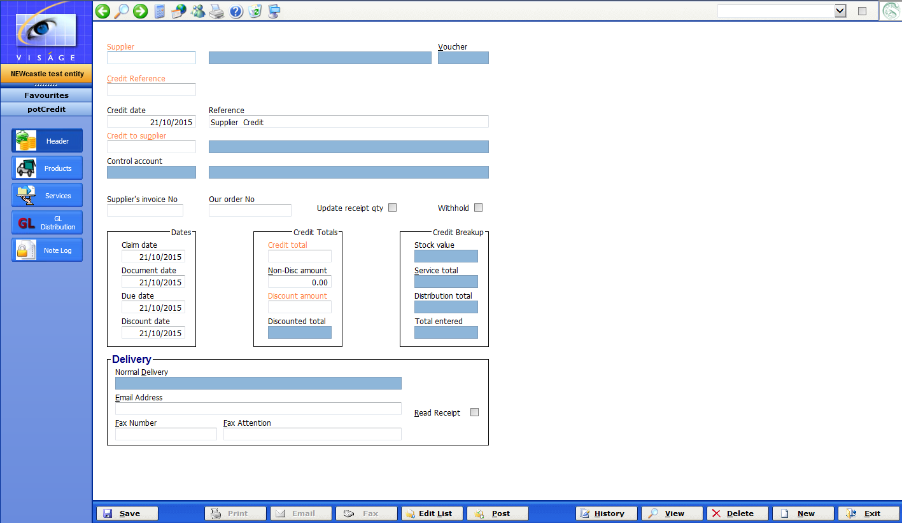

- Supplier - This is the unique code for the Supplier that this credit applies to. Use Search facilities to locate Supplier Code if it is not known.

- Credit Reference - This is a unique number that can be used to identify the credit in the system. This number will be system generated when you click the Save button or if you prefer you can manually enter a unique number in this field.

- Credit Date – This is the date the credit was raised on.

- Reference – This is an optional reference field. Enter a meaningful reference or this field can be left blank.

- Credit to Supplier – This is the code for the supplier whose account this credit will reduce. Use Search facilities to locate Supplier code if it is not known.

The Supplier and Credit to Supplier fields can be the same, but they may sometimes be different. They might be different in a Branch situation, where goods might be supplied from Branch XYZ but the Pay to Supplier might be the Head Office.

- Supplier’s Invoice No – This is the Invoice from the Supplier that is being credited here. This can print on the Supplier Credit form to provide your Supplier with information as to the source of the purchase.

- Our Order No – This is our Purchase Order number that was used to order the items being credited. This can print on the Supplier Credit form if required. This can be left blank if there was no Order number created.

- Update Receipt Qty – Check if you wish to reduce the quantity received on the Purchase Order with the qty you are currently crediting.

- Withhold – Check if you need to withhold tax from this Supplier if they have not supplied you with their ABN.

- Dates:
  - Claim Date – This is the date the credit is claimed for. Should be the same as Credit Date.
  - Document Date – Used to calculate due and discount dates. Will normally be the same as claim date.
  - Due Date – This is the date payment will be due for vouchers generated from this credit. The system will calculate this based on the Supplier’s Trading Terms; however you may change this if required.
  - Discount Date – If payment is made on or before this date, then the discount amount can be deducted from the payment. If payment is made after this date, then the full invoice amount will normally be paid.

- Credit Totals:
  - Credit Total – This is the total amount for this credit.
  - Non-Disc Amount – This is the amount of this credit that will not be discounted. Leave blank if this is not applicable to you.
  - Discount amount – This is the amount of discount to be allowed for this credit. Leave blank if this is not applicable to you.

- Delivery
The details that default here are the details entered in apmSupplier process for the supplier code entered in the first field of this process.

These details are used for sending details of this supplier credit to the nominated supplier by either email or fax.

  - Normal Delivery – This is a display field and will default with the details from Order delivery address details in apmSupplier. Options are: Fax, Email or Print.
  - Email Address – This will be the email address to be used if the Normal Delivery is set to email. This field can be changed if required.
  - Read Receipt – Check this option if you wish to receive a Read receipt from your Supplier when this Supplier Credit has been sent via email. This is provided your Supplier’s email client supports sending read receipts.
  - Fax Number – This will be the fax number to be used if the Normal Delivery is set to Fax.
  - Fax Attention – Indicates who this credit will be marked to the attention of, where the credit is being faxed.

PRODUCTS SCREEN

This is the screen where the details of the Products to be credited are entered.

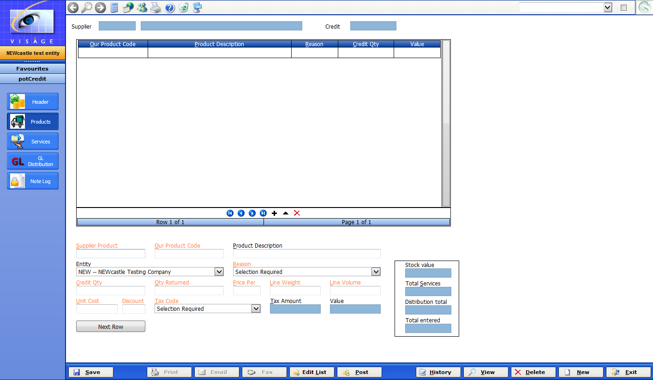

- Supplier Product – This is the Supplier’s product code. It may be the same as your product code.

- Our Product Code – This is your Product Code for the goods being credited.

When goods are ordered in the system via the Purchase Order potOrders process, a link is created between the Supplier Product and Our Product Code.

When a Supplier Credit is created – the system checks to see if there is a link between a Supplier product and our product and if there is, when entering the Supplier Product in this process will look up the link and our Product Code will be displayed automatically. If there is no link you should enter the applicable code in Our Product Code field.

- Product Description – This is a description of the product.
- Entity – Select the Entity from the available list this credit line is for.
- Reason – Select the reason for this credit from the available list. Reasons are maintained in the pomReturnReasons process.
- Credit Qty – Enter the number of items that you are claiming a credit for. This quantity can be different to the Qty Returned figure.
- Qty Returned – Enter the quantity of this product that is actually being returned to the Supplier. The quantity on hand of this item will be reduced by this quantity.
- Price Per – Used to calculate the extension, in conjunction with Unit Code, Tax Code and Quantity, Weight or Volume.
- Unit Cost – This is the unit cost we are claiming.
- Discount – Used when calculating the line amount. Leave default of 0.00 if no discount is applicable.
- Tax Code – Will default with Tax Code used for this product from Inventory system.

Press <Enter> after the Tax Code field to add another row to the table or click on the + or the Next Row button to add another row to the Table. Click on the Delete row button to remove a row from the table.

Click on the Save button when you have completed all entries for Products on this screen.
SERVICES SCREEN

Use this screen to enter details of any Service types that you are requesting a credit for.

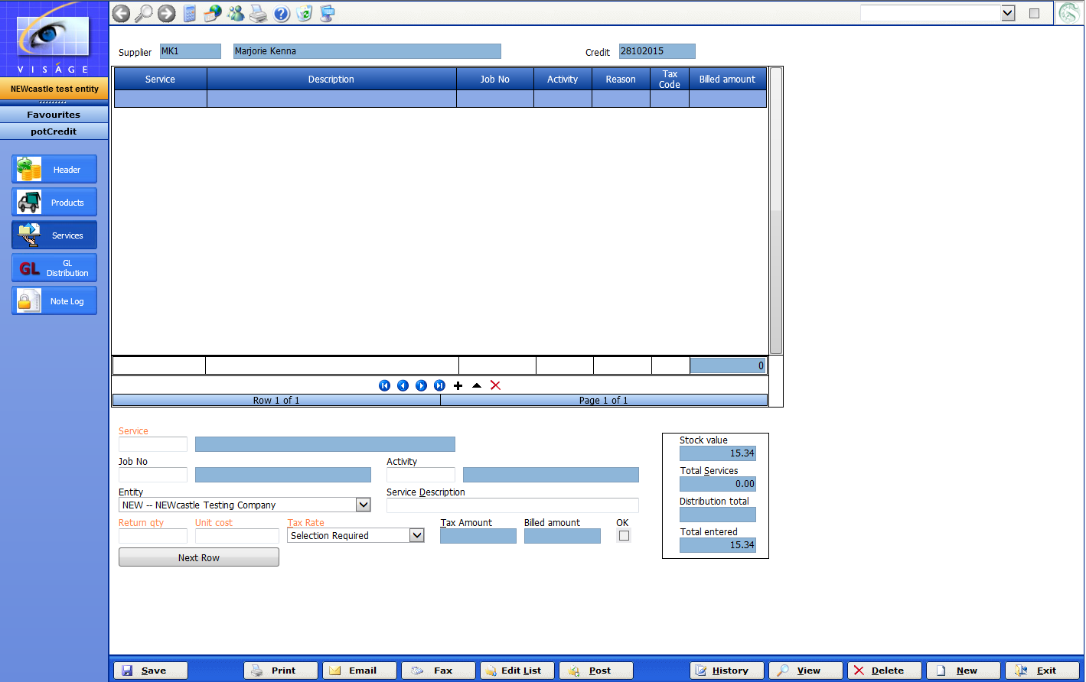

If there are no service details to claim credits for, do not enter any details in this screen.

- Service – This is the Service Code for this line that a credit is being raised for.
- Job No – If this credit line refers to materials or services that were originally purchased for a job, and which were originally distributed to that Job, then enter the Job Number here. If no distributions took place to Jobs, then leave this field blank.
- Activity – This field can be used to further sub-classify an expense for the purposes of Job Costing if you have nominated that you wish to maintain activity costing.
- Service Description – This is a description for this service line.
- Return Qty – Enter the Quantity being returned.
- Unit Cost – Enter the Unit cost for this service item.
- Tax Rate – Select the Tax Code for this service line.
- Entity – Select Entity from available list.

Press <Enter> after the Tax Code field to add another row to the table or click on the + or Next Row button to add another row to the Table. Click on the Delete row button to remove a row from the table.

Click on the Save button when you have completed all entries for Services on this screen.
GL DISTRIBUTION SCREEN

Use this screen to enter details of any General Ledger distributions that are not associated with Products or Services.

If there are no GL Distribution details to claim credits for, do not enter any details in this screen.

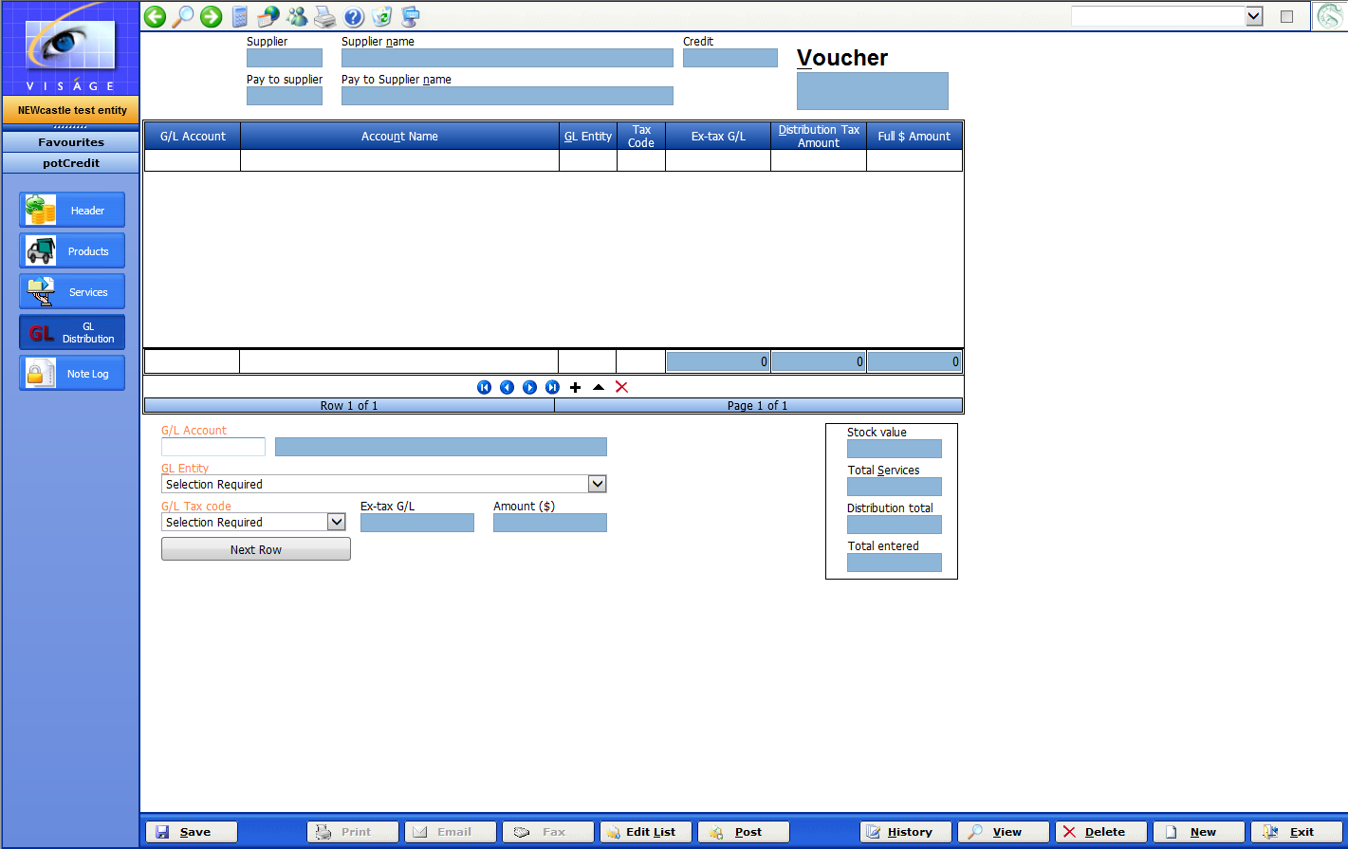

- G/L Account – This is the General Ledger Account to put any distributions to that are not associated with Products or Services.

- G/L Entity – This is the Entity to which any extra distributions will be costed.

- G/L Tax Code – Select the Tax Code for this distribution.

Press <Enter> after the Tax Code field to add another row to the table or click on the + or the Next Row button to add another row to the Table. Click on the Delete row button to remove a row from the table.
Click on the Save button when you have completed all entries for this screen.

NOTE LOG SCREEN
This allows you to record any information relevant to this Supplier Credit entry that may be of use for future reference.
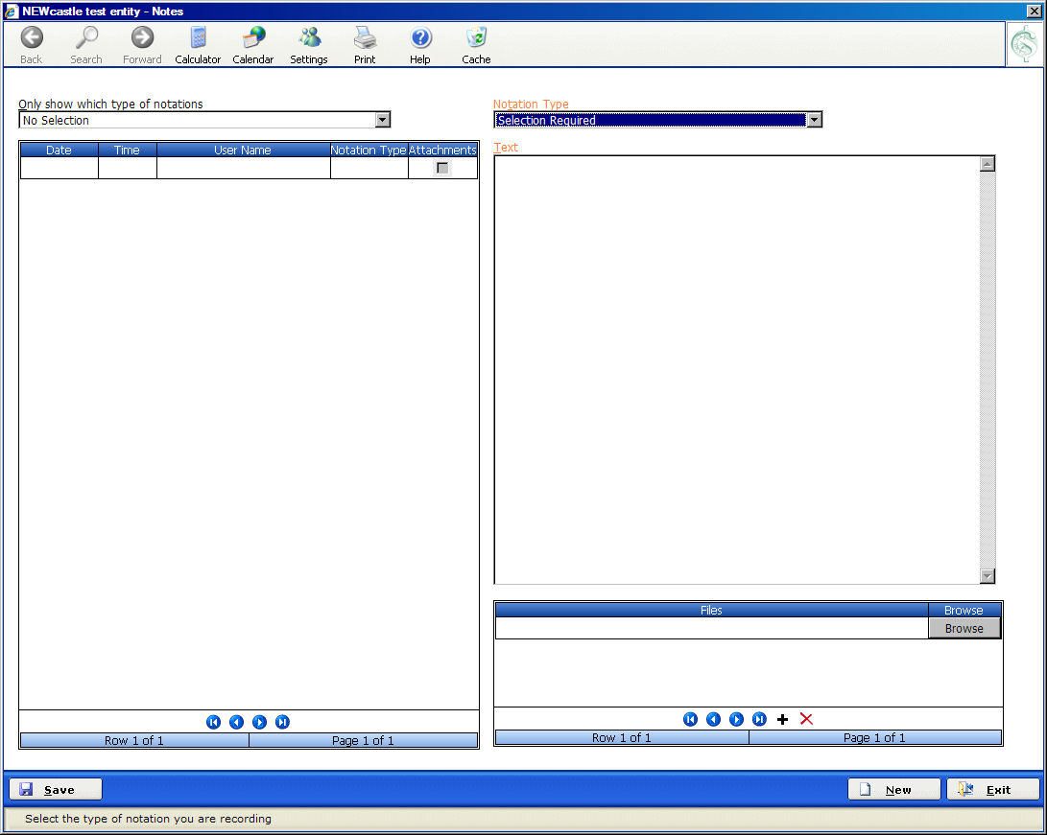

Using this area is optional.
- Notation Type – Select option from available list. Notation types are maintained by the ssmNotetype process.
- Text – Enter the free form text that you wish to record here.
- Files – If you have any files that you would like to store in this Note Log, click on the Browse button and locate the files.

Click Save to save any information.
Click Exit to return to the Supplier Credit process.
SUPPLIER CREDITS EDIT LIST
Review the Supplier Credit Adjustment list to make sure your entries are correct prior to running the Supplier Credits post process.
SUPPLIER CREDITS POST
Run this process when you are satisfied the entries are correct. This process will update the related systems.

